# **Class 1. LSTM | Long Short Term Memory | Part 1**

<https://colah.github.io/posts/2015-08-Understanding-LSTMs/>

[lstm-projectipynb](https://colab.research.google.com/drive/1f552_XYv9N6lJ5lSYKQ2pSu0f3pZQQn4?usp=sharing)

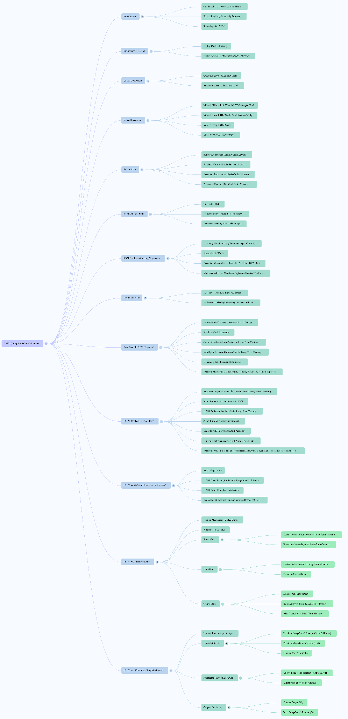

# **LSTM | Long Short Term Memory | Part 1 | The What?**

LSTMs are introduced as the next topic. **LSTMs are a very important topic in the industry and are considered a foundational step for understanding newer concepts like LLMs, Transformers, and Attention mechanisms**. The speaker notes that LSTMs are generally labelled as a **difficult topic** to understand, not just how they work, but crucially, *why* they work. This video is the first of a planned four-part series on LSTMs, focusing on "What" LSTMs are (the simple idea).

**Recall: Problems with Simple Neural Networks and RNNs**

* Simple Neural Networks (NNs), like fully connected ones, are **not able to handle sequential data**. Sequential data, such as text or time series, is where **chronology matters**, and past points impact future points.
* With simple NNs, a whole sentence might be converted to numbers and sent through the network at once, meaning the **order of words loses its meaning**.
* **RNNs were developed to solve this problem by introducing the concept of "State"**. In an RNN, each hidden unit feeds back into itself and others in the next time step, allowing inputs to be processed **one word at a time**. The state allows the network to maintain some memory of previous inputs.
* However, RNNs struggle with **long sequences**. If a decision depends on information from the very beginning of a long sequence, an RNN might **forget** the initial information because the short-term context tends to dominate the single state.
* This problem is due to a mathematical issue called the **Vanishing/Exploding Gradient Problem**, especially when the chain of dependencies becomes very long. LSTMs originated precisely because RNNs were not able to handle long sequences effectively due to this gradient problem.

**Core Idea of LSTMs: Handling Long Sequences and Memory**

* The **core idea of an LSTM is inspired by how the human brain processes sequential data**, like a story.
* The brain processes data word by word. It maintains a **short-term context** of what's happening right now.
* Crucially, the brain also tries to build a **long-term context** from the short-term context.
* It decides **what is important** from the current input/short-term context to keep for the long-term context.
* It can also **remove information** from the long-term context if it becomes irrelevant.
* **This is the core idea behind LSTMs**.
* 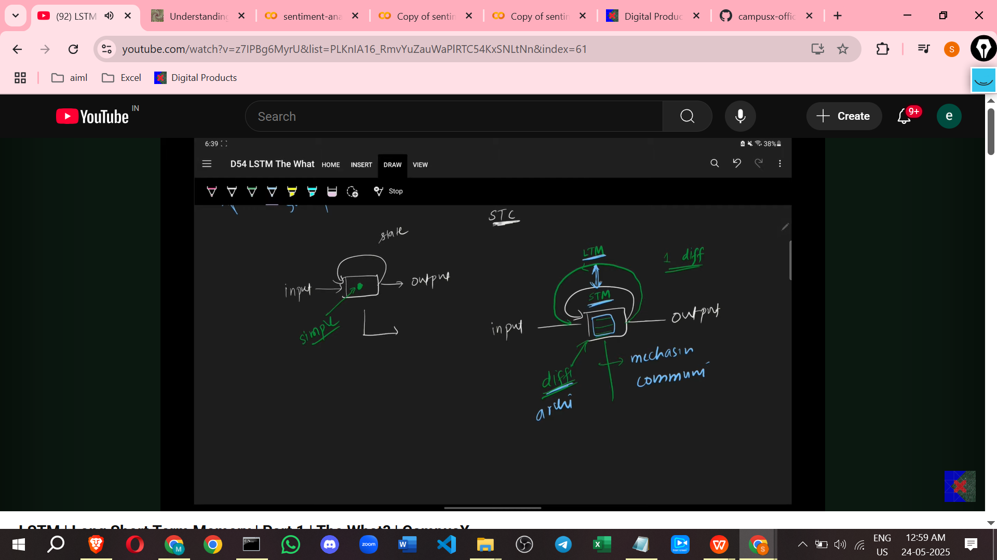

**LSTMs vs. RNNs: Architectural Differences**

* RNNs maintain memory using a **single line or path** (a single state). This single line is responsible for maintaining both **short-term and long-term context**. Mathematically, this single variable struggles to hold both, and the **short-term context tends to dominate**, causing older, long-term information to be forgotten.
* **LSTMs address this by introducing an additional path to maintain memory**. There is a lower path for **short-term memory** (carrying information from the immediate input) and an upper path for **long-term memory**. Information identified as important early in the sequence can **reach the end** via the long-term memory path, provided it is not removed.
* The LSTM architecture is **more complex** than an RNN. This complexity is needed to allow the short-term and long-term memories to **communicate** with each other. The short-term memory needs to tell the long-term memory what new important information has arrived or if something needs to be removed. This communication mechanism requires a **complex internal architecture**.

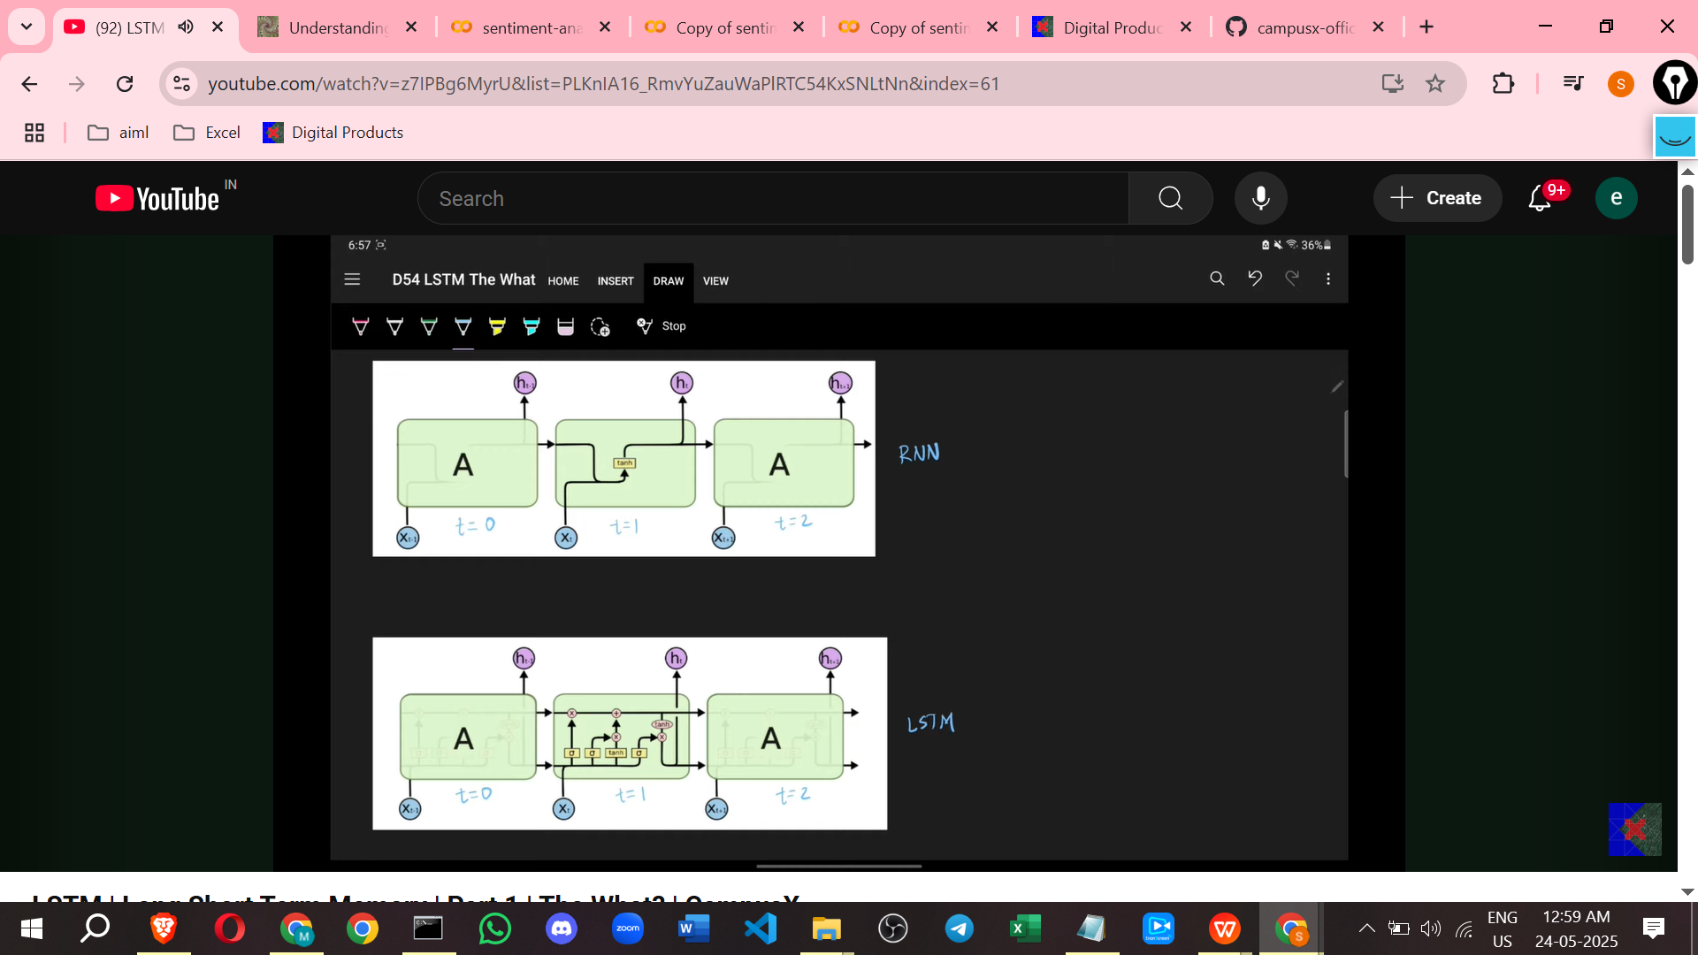

**LSTM Internal Architecture: Gates**

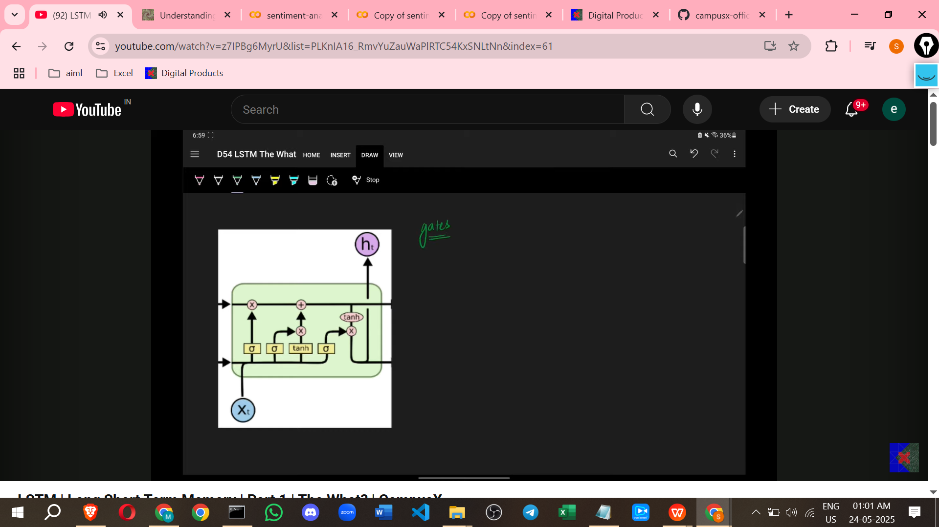

* The complex internal structure of an LSTM consists of components called **"gates"**.
* An LSTM typically has **three main gates**.
* These gates handle the **communication** between the short-term and long-term memory paths.

Here is a one-line description of each gate as provided:

1. **Forget Gate:** Based on the current input and short-term context, it **decides what to remove** from the long-term memory.
2. **Input Gate:** Based on the current input, it **decides what new information to add** to the long-term memory.
3. **Output Gate:** Based on the current input and the current state of the long-term memory, it **produces the final output**. The Output Gate also **creates the short-term memory** (or hidden state) for the next time step.

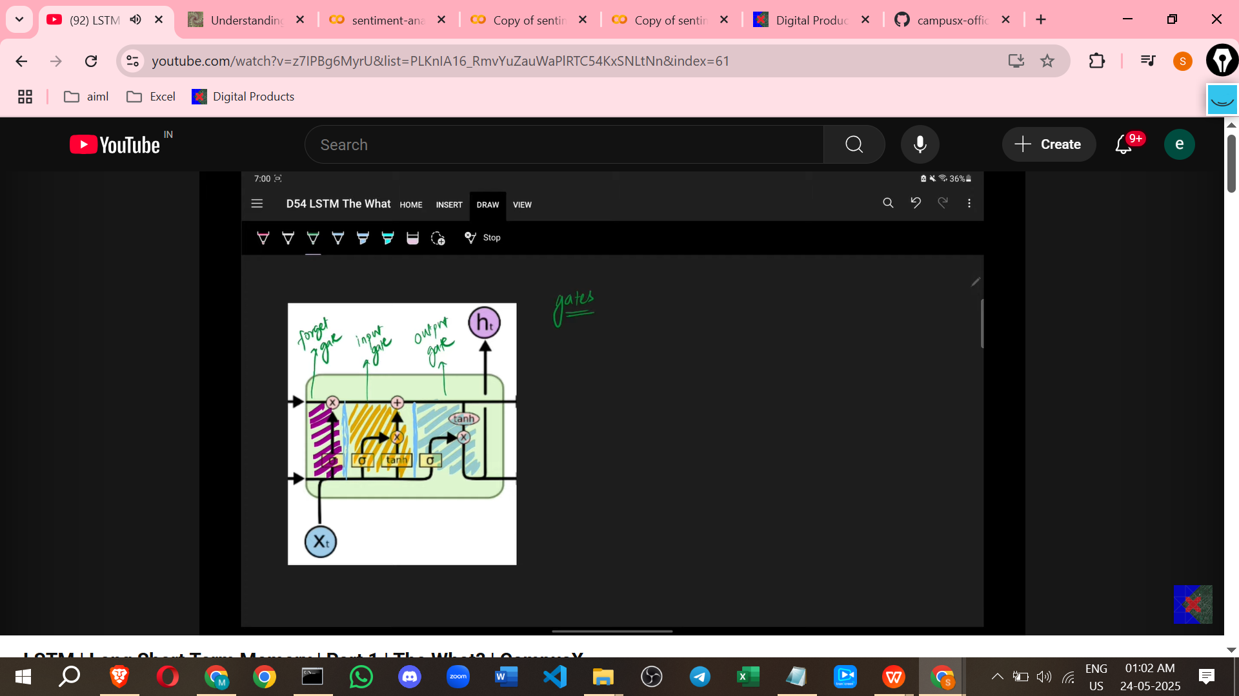

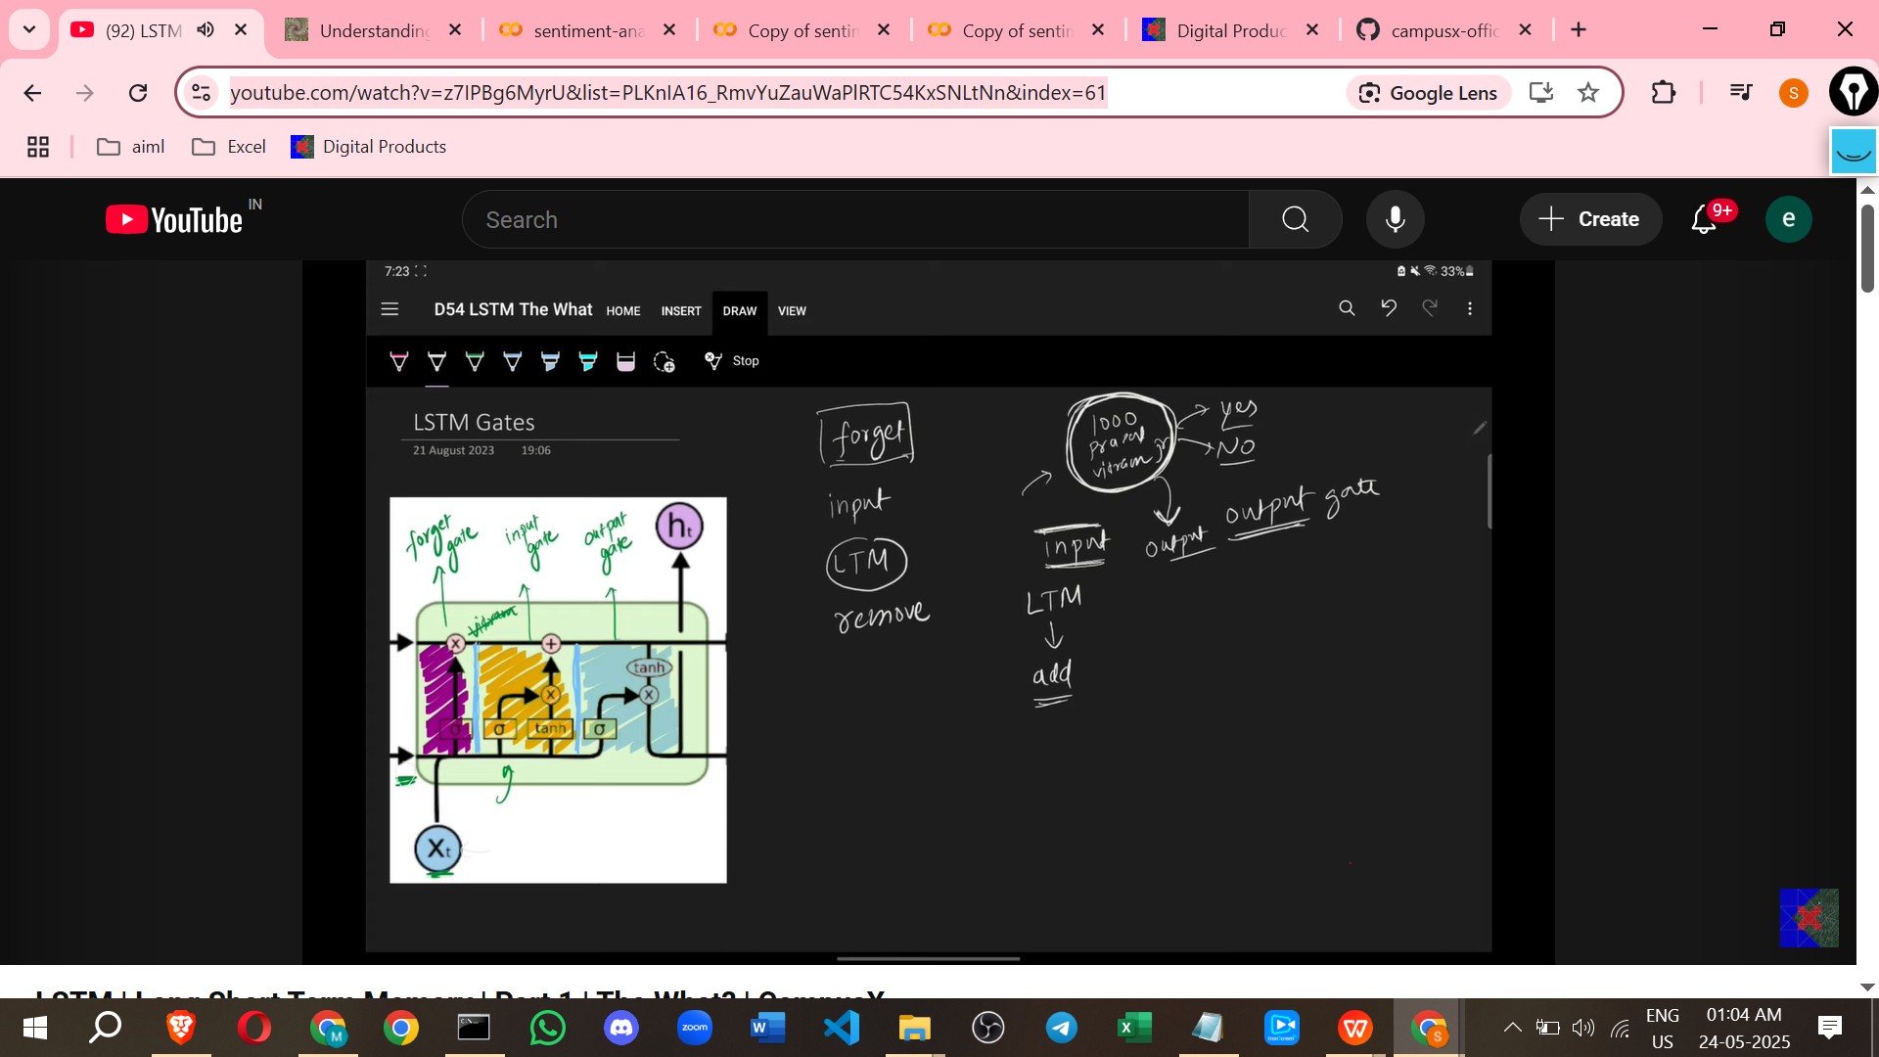

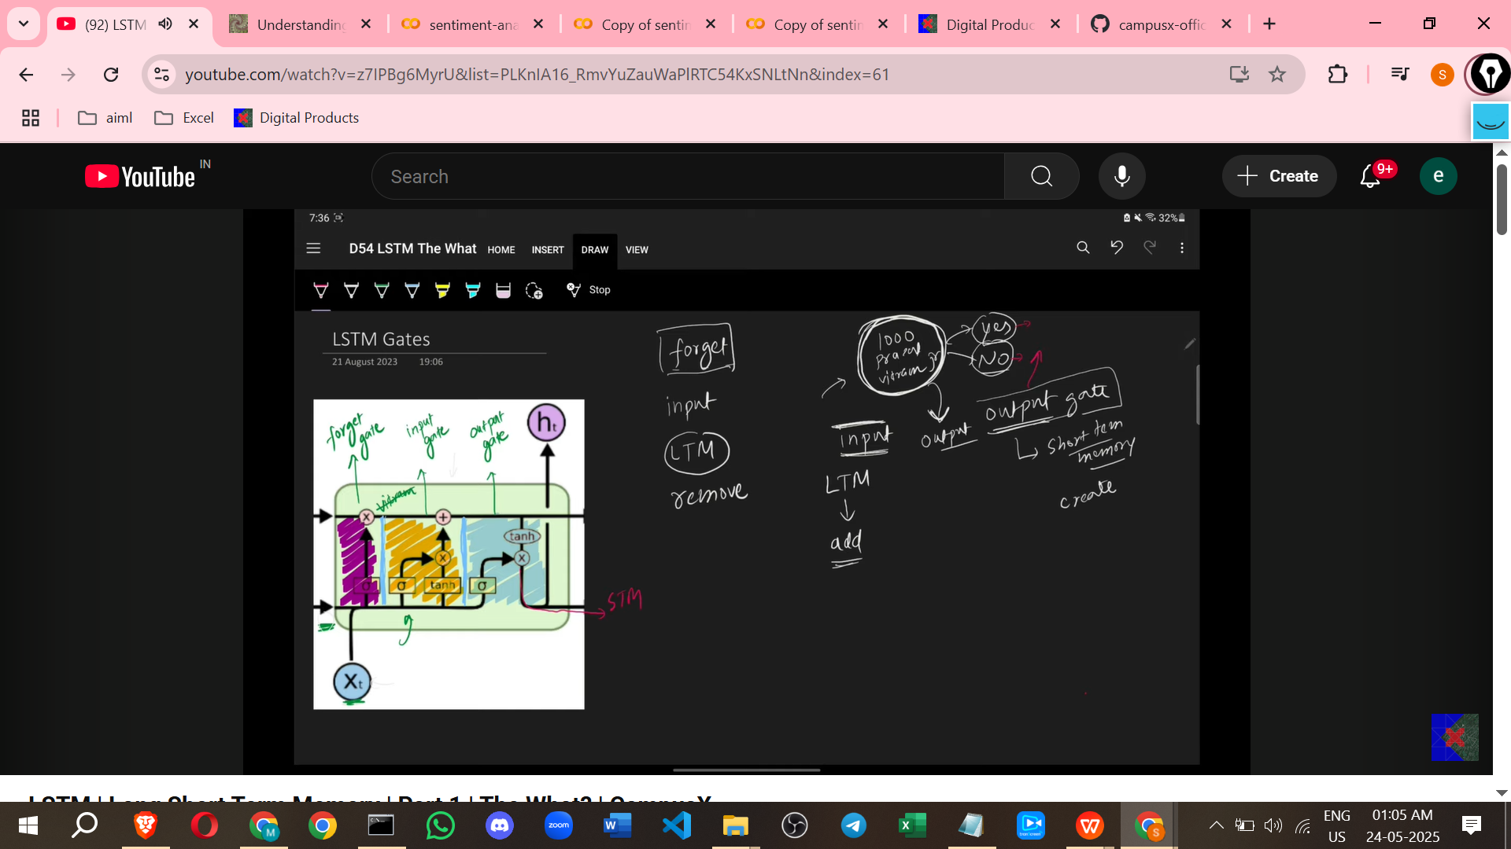

**The Story Analogy and How It Relates to LSTMs**

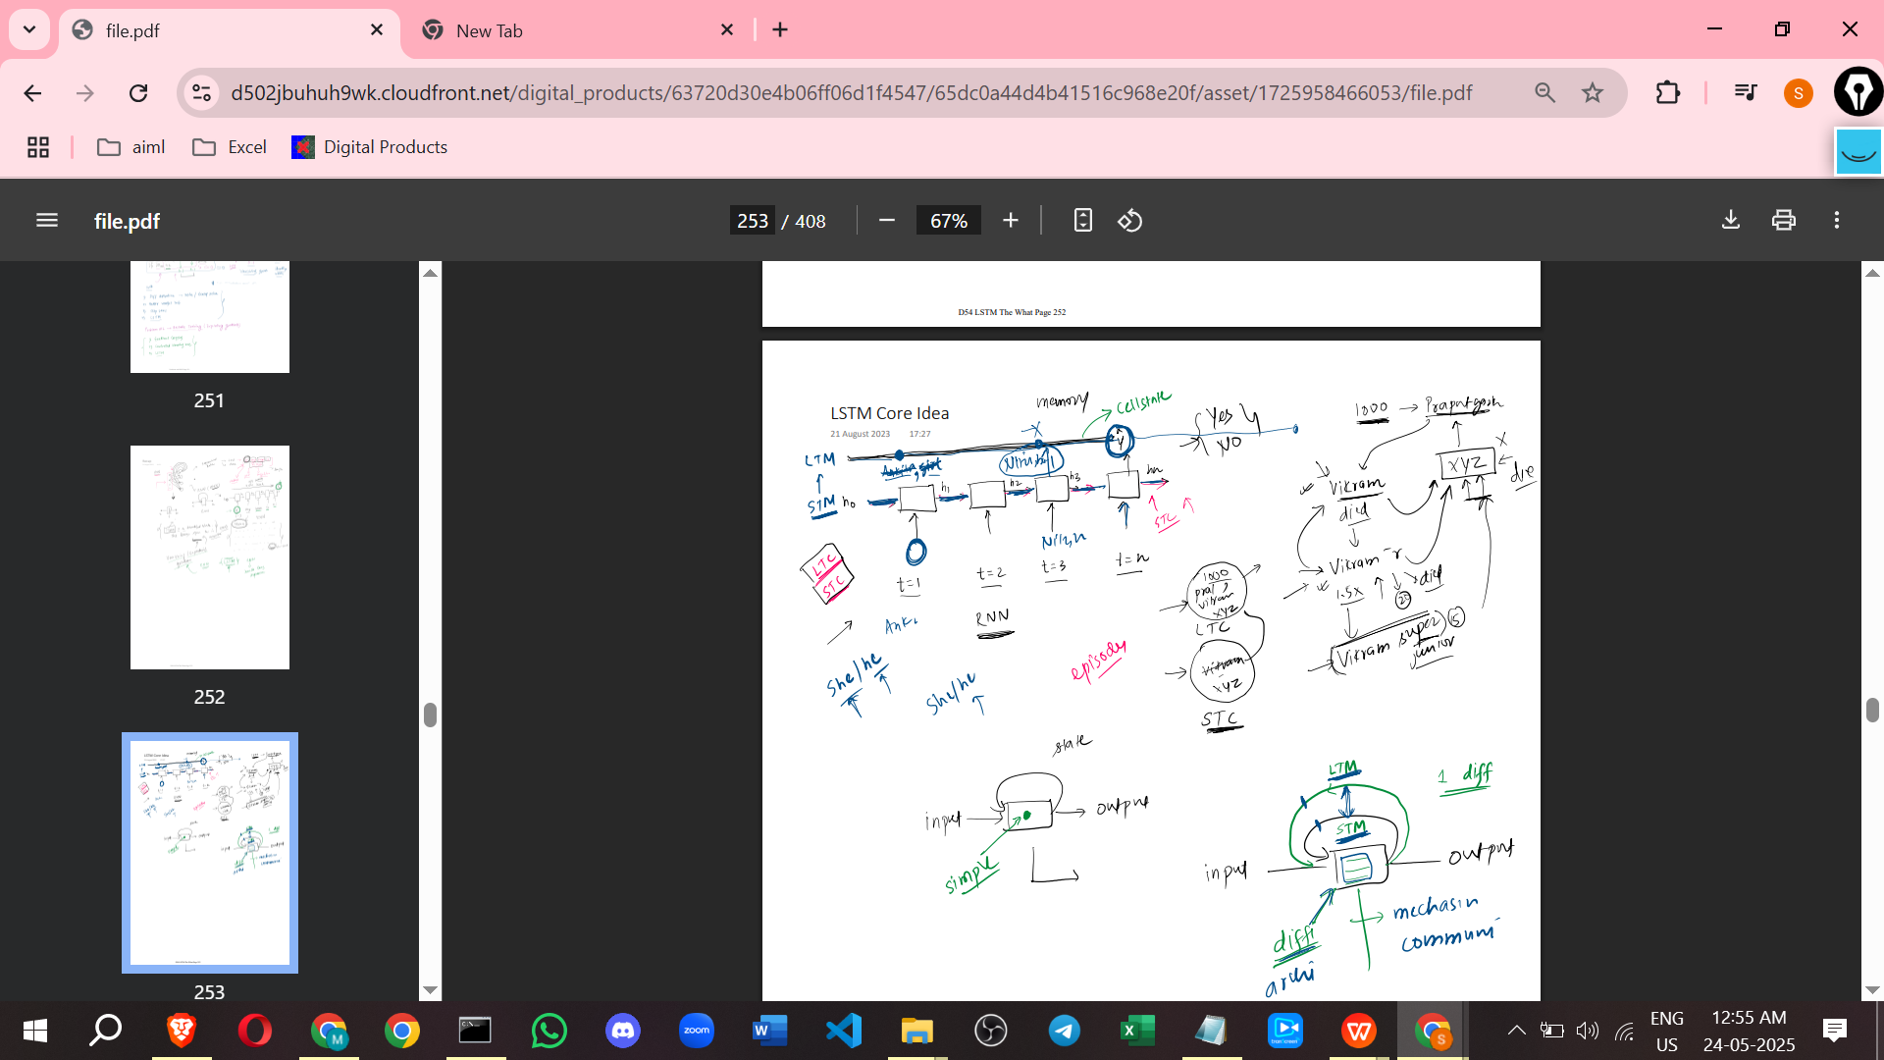

The speaker uses a story analogy to explain the core idea of LSTMs. The task is to listen to a story and decide if it is good or bad, acting like a text classification network. The key is *how* this decision is made.

The story is about a king named Vikram who ruled a state called Pratapgarh a thousand years ago. Vikram was powerful, kind, and a good king. Suddenly, a neighbouring king, XYZ, attacked. A fierce war occurred, Vikram fought bravely, defeated XYZ, but Vikram **died**. Everyone mourned.

His son, **Vikram Junior**, became king. Vikram Junior was even more powerful and attached to his people than his father. However, he wanted revenge on XYZ. When Vikram Junior turned 20, he attacked XYZ, there was a terrible fight, and Vikram Junior also **died**.

Then, Vikram Junior's son, **Vikram Super Junior**, became king at age 15. Vikram Super Junior was not as strong as his father or grandfather, but he was very smart. He also wanted revenge. He attacked XYZ, was initially dominated, but used his intelligence and **killed XYZ**, avenging his father and grandfather.

Finally, you are asked if the story was good or bad.

**How this relates to LSTMs (the Brain Analogy)**

When processing this story word by word, your brain does the following:

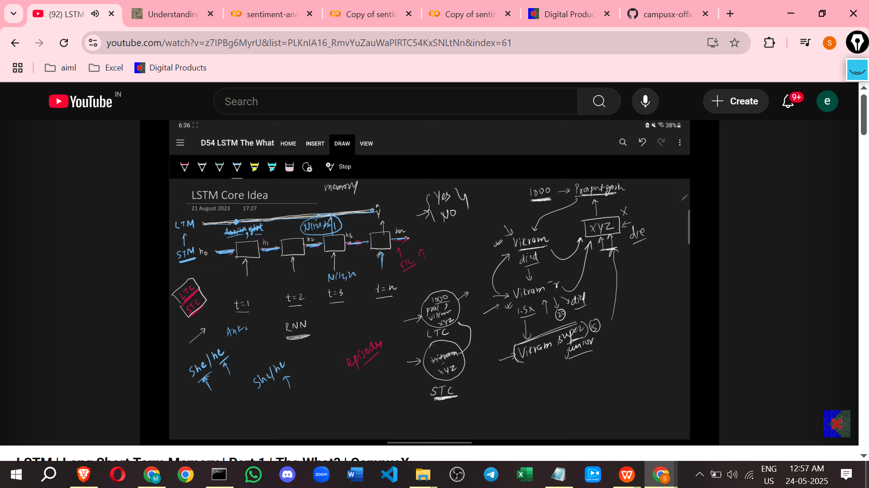

* **Processes word by word:** Like an RNN/LSTM, it takes the input sequentially.
* **Maintains Short-Term Context:** Keeps track of what's happening *right now*.
* **Builds Long-Term Context:** Continuously tries to build a long-term context from the short-term context.
* **Decides What's Important (Input Gate Analogy):** When it hears "Thousand years ago," it might add "History story, no guns" to the long-term context. When it hears "Pratapgarh," it might add "Geography matters". When it hears about **Vikram** being powerful and kind, it might add "Vikram is the hero" to the long-term context. When **Vikram Junior** is introduced as more powerful, it might add "Vikram Junior" to the long-term context. When **Vikram Super Junior** is introduced, it might add "Vikram Super Junior" to the long-term context.
* **Decides What to Remove (Forget Gate Analogy):** When you hear that **Vikram** *died*, your brain might remove "Vikram is the hero" from the long-term context. When **Vikram Junior** *died*, your brain might remove "Vikram Junior is the hero" from the long-term context.
* **Produces Output (Output Gate Analogy):** At the end, when asked if the story was good or bad, your decision is based on the *ending* (current input) and what remains in your *long-term memory* (Vikram Super Junior successfully avenging).

**LSTM Process Summary (Simplified)**

* An LSTM can be thought of like a computer: it takes **input**, performs **processing** inside, and gives **output**.

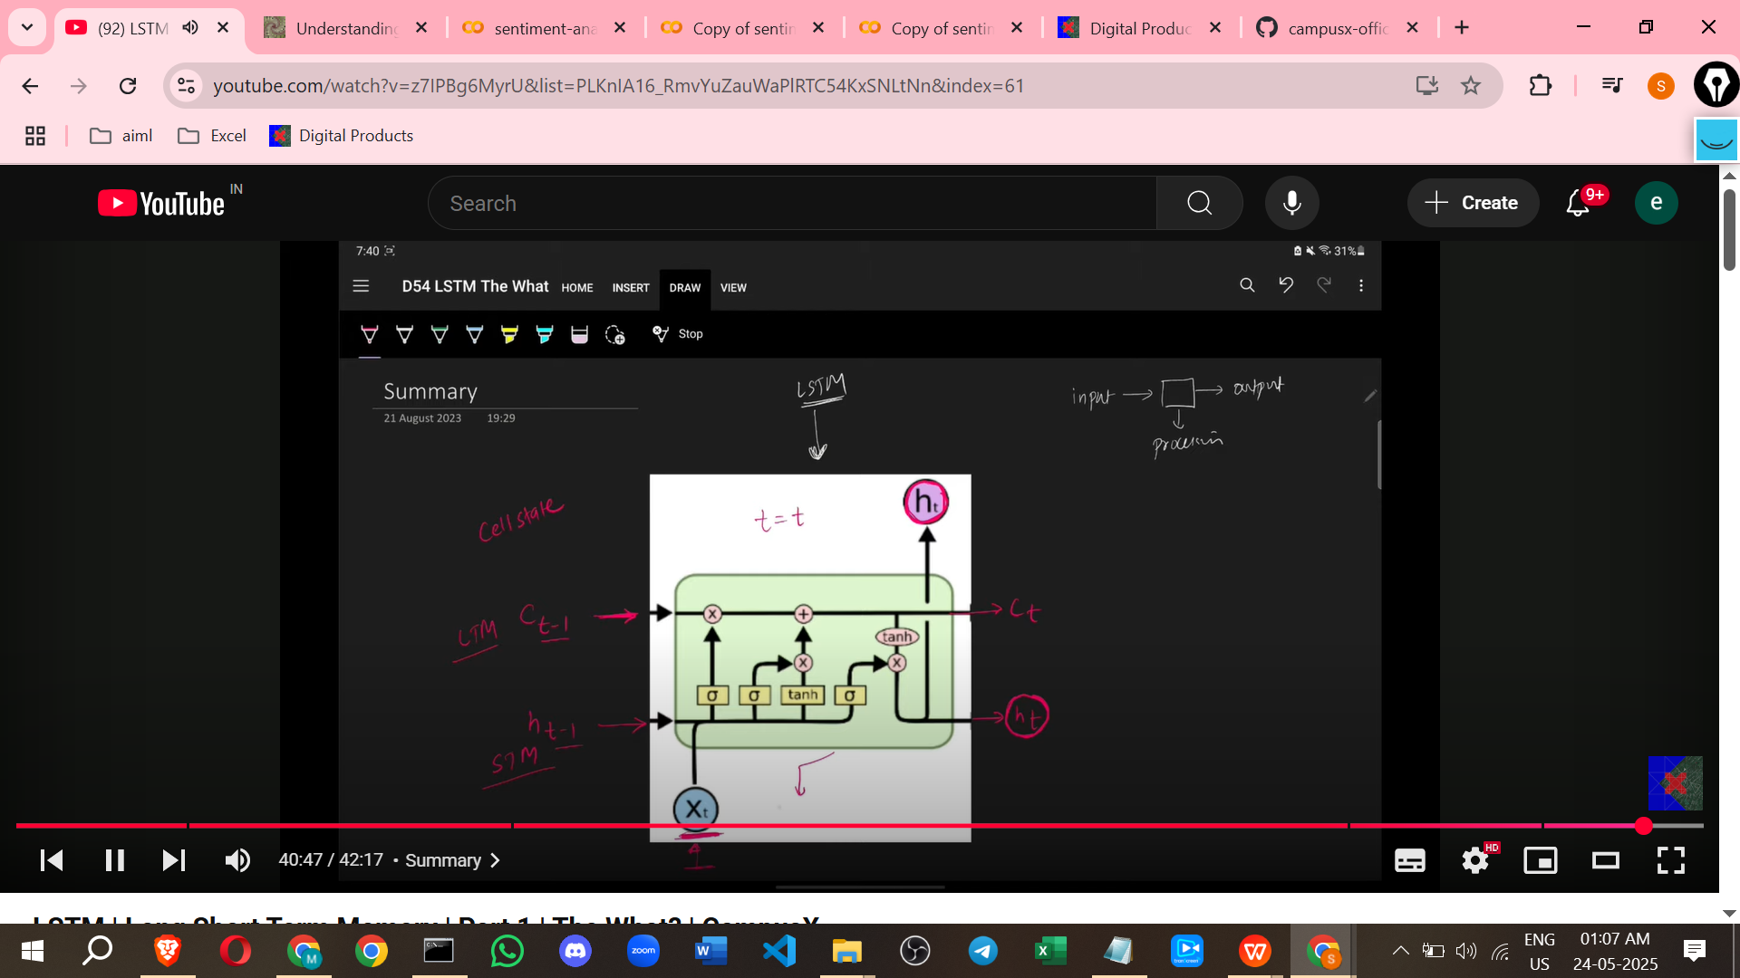

* At each time step (t), the inputs are:
  + The **Long-Term Memory** (or Cell State) from the previous time step (Ct-1).
  + The **Short-Term Memory** (or hidden state) from the previous time step (Ht-1).
  + The **Current Word** input (Xt).
* Inside the LSTM cell, two main things happen:
  + The **Long-Term Memory (Cell State)** is **updated** (old things are removed, new things are added).
  + The **Short-Term Memory (Hidden State)** for the next time step (Ht) is **created**.

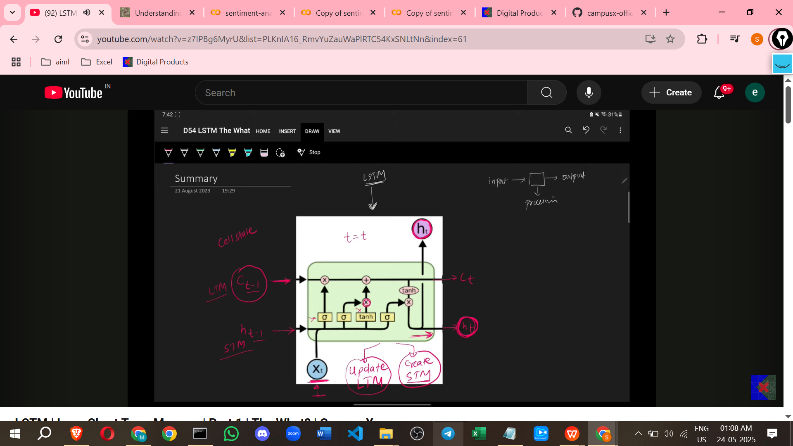

* The outputs from the LSTM cell at each time step are the updated **Long-Term Memory (Ct)** and the new **Short-Term Memory (Ht)**.

This covers the "What" of LSTMs as discussed in this video. The subsequent videos will delve into the "How" (architecture, mathematics) and the "Why" LSTMs work.

===========================================================

# **Class 2. LSTM Architecture | Part 2 | The How?**

<https://colah.github.io/posts/2015-08-Understanding-LSTMs/>

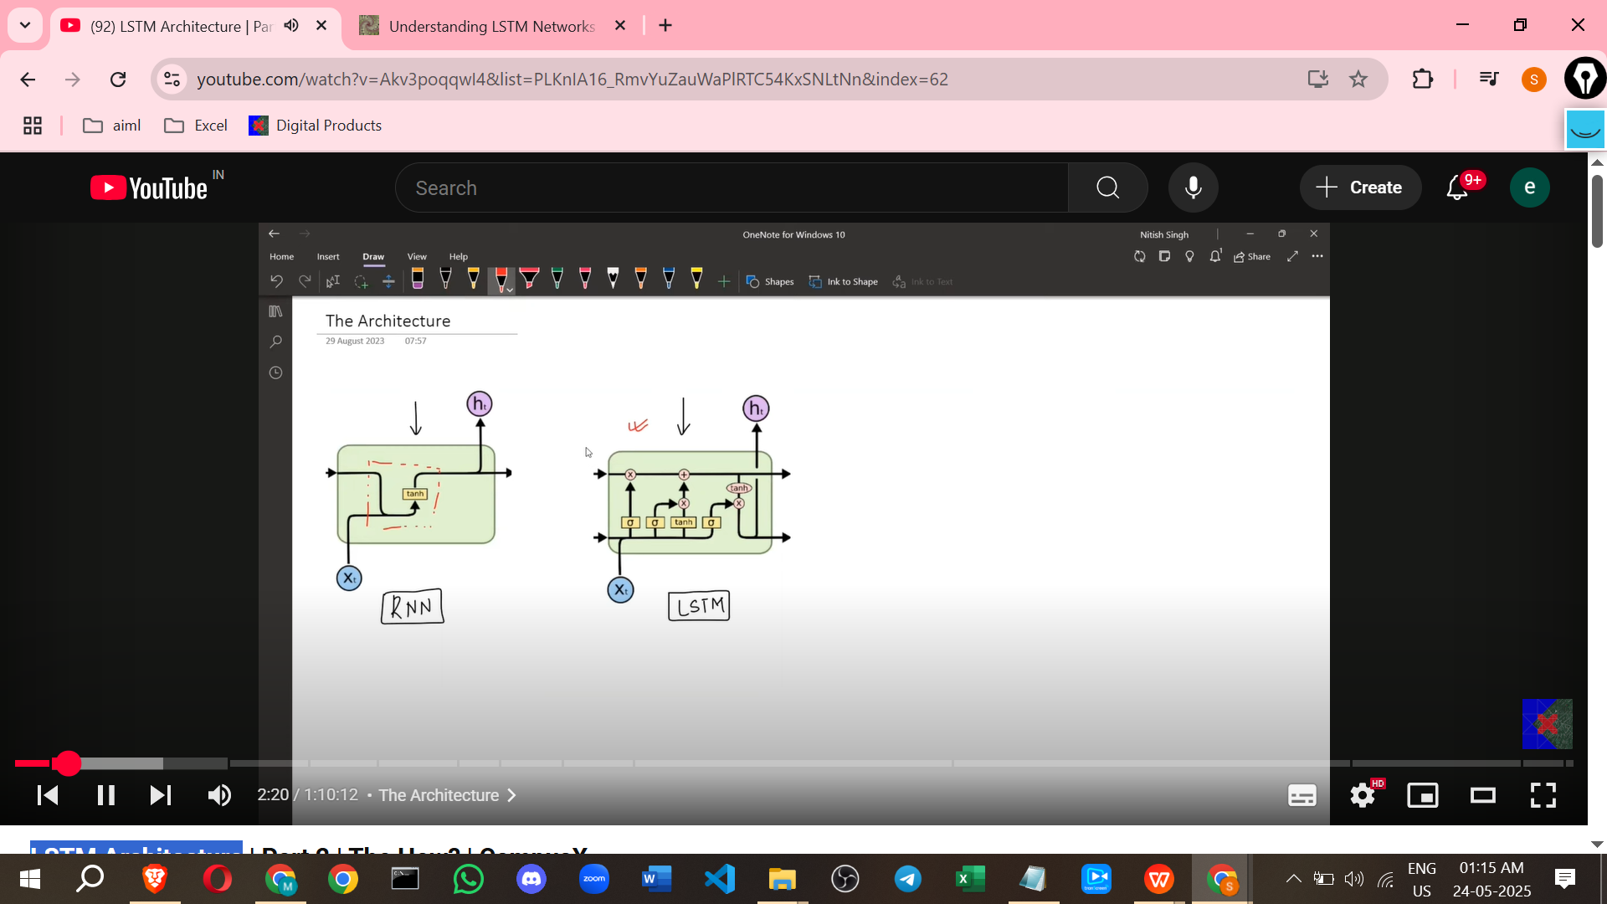

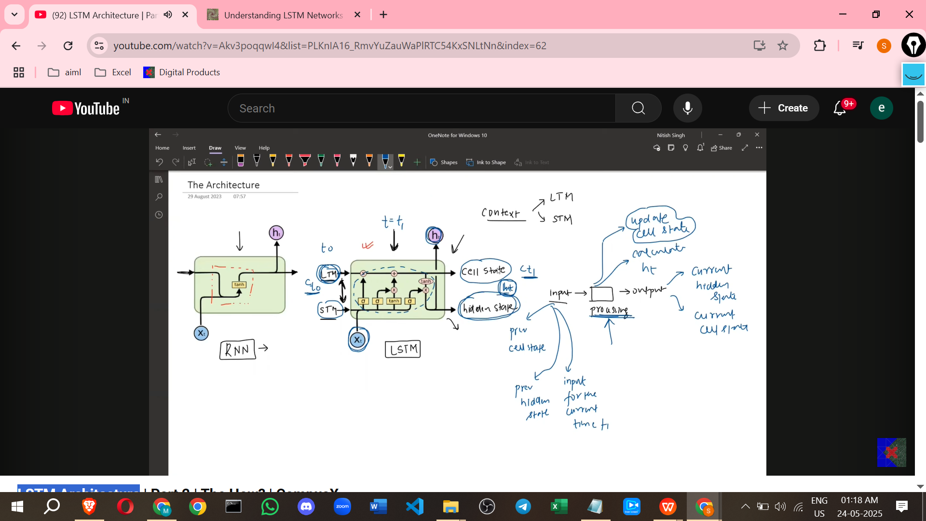

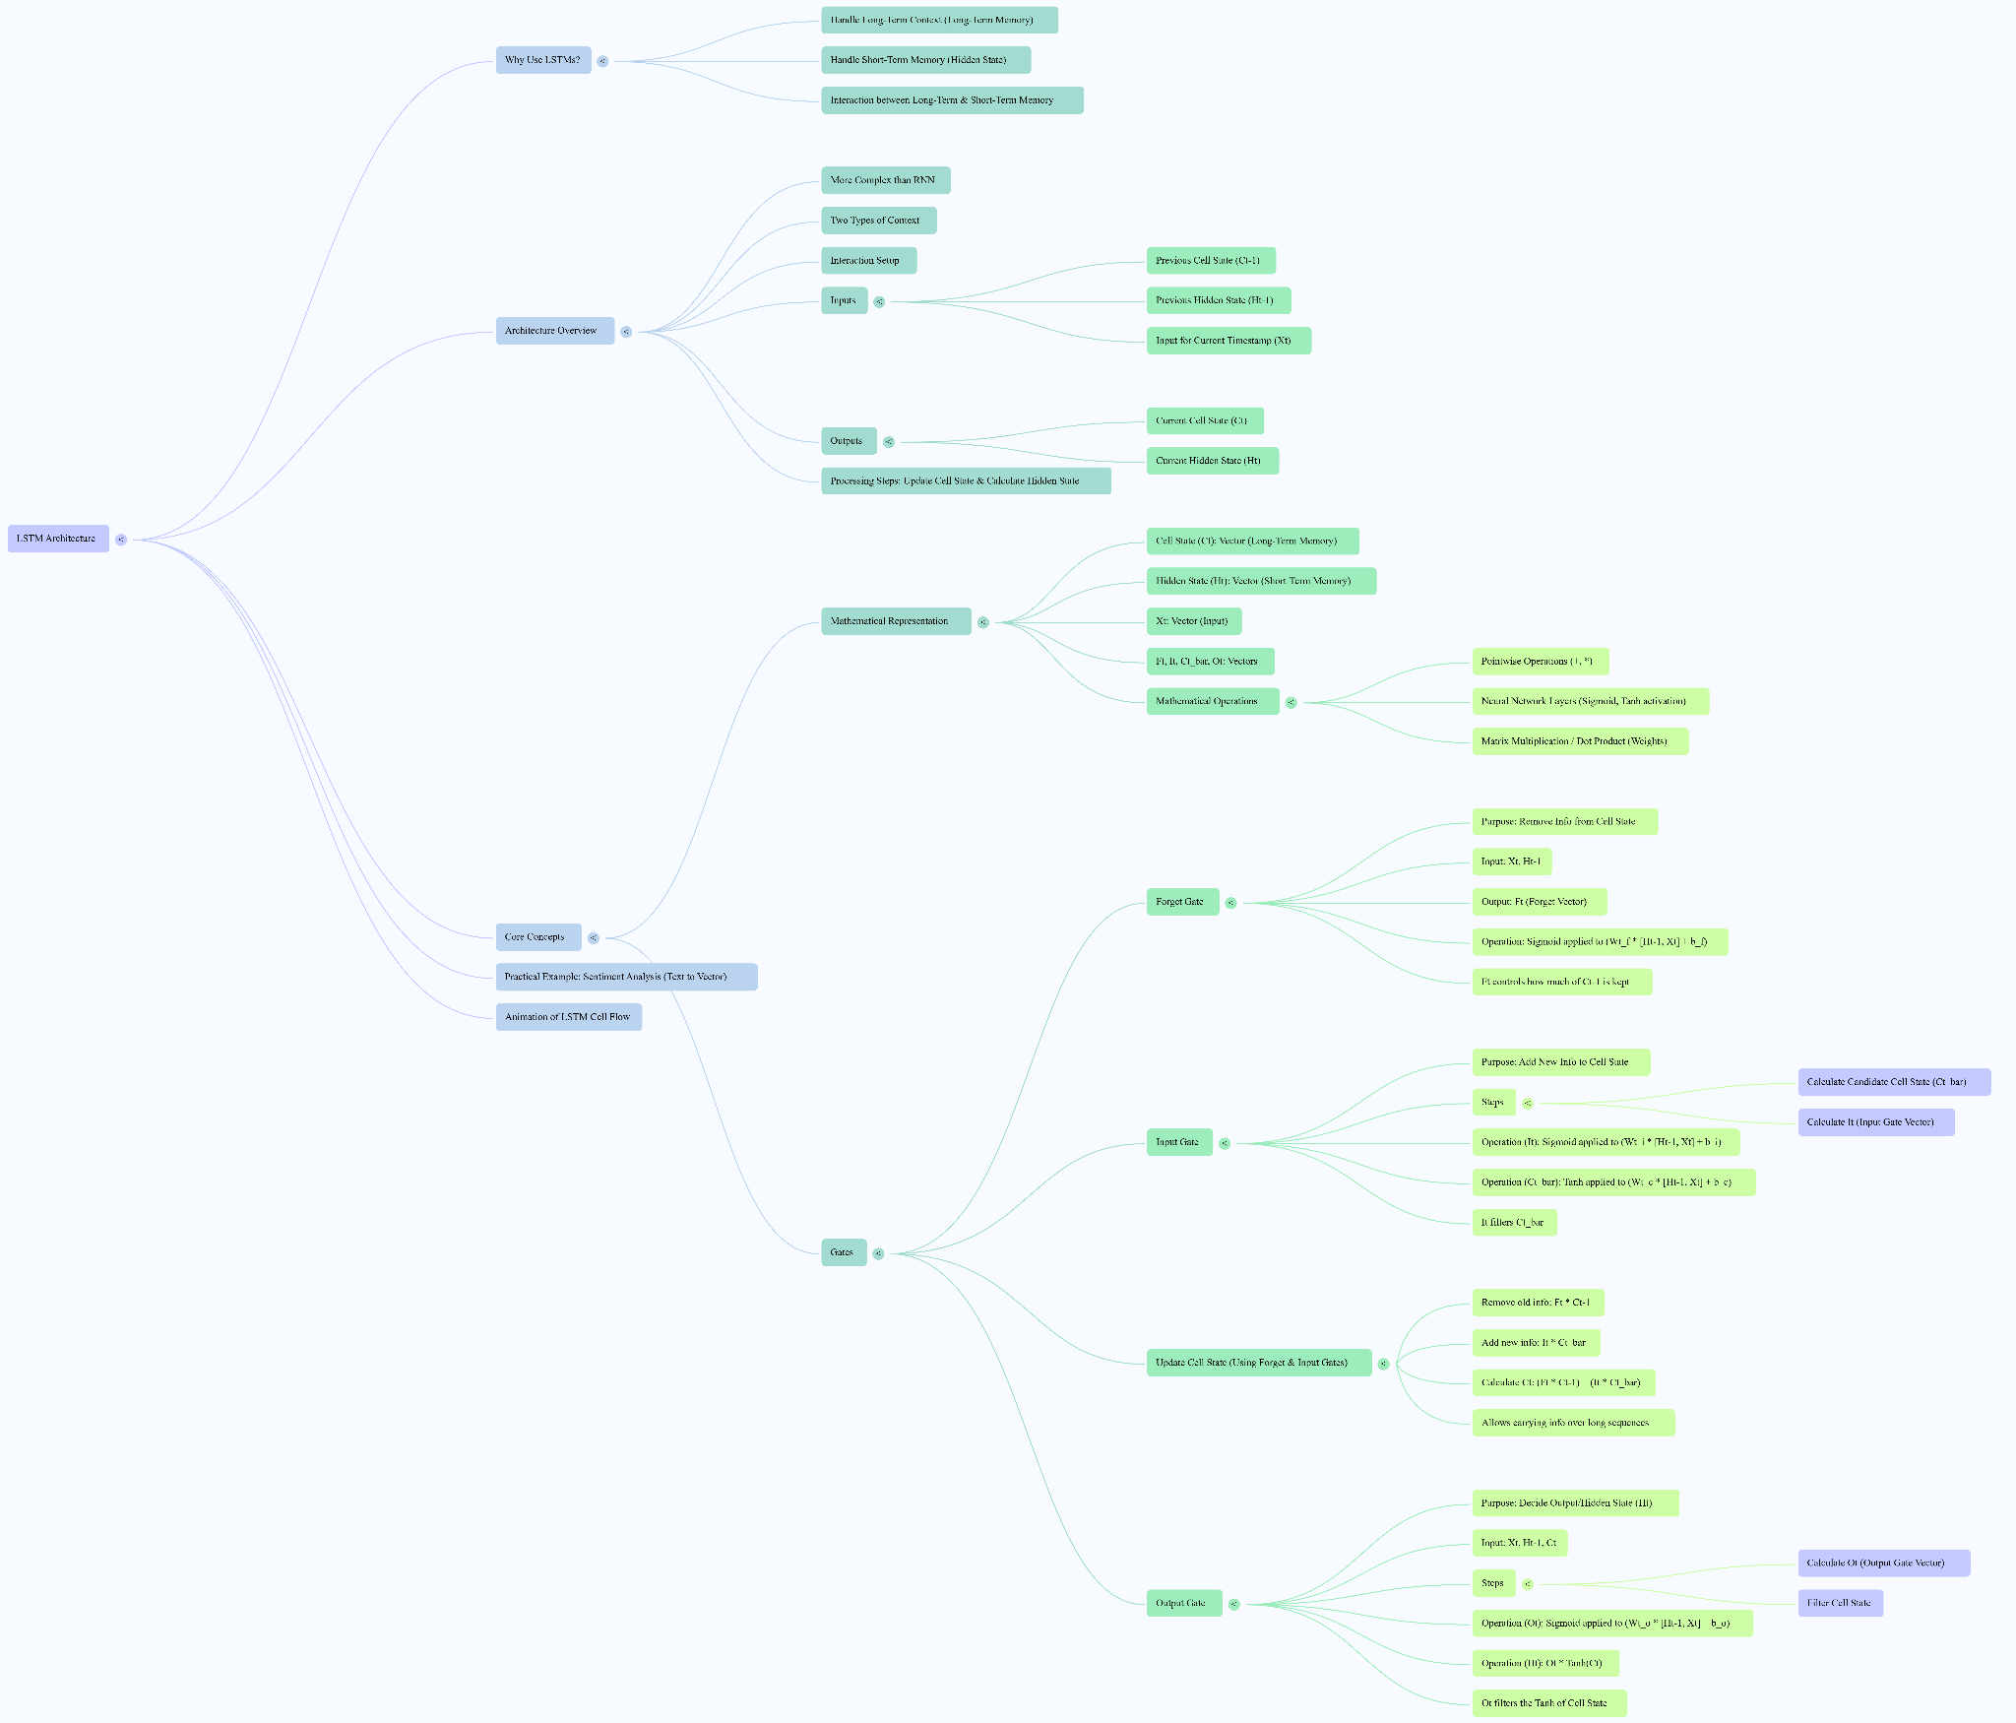

**Notes on LSTM Architecture**

previous ones that introduced LSTMs and covered RNNs.

* **Difficulty:** Understanding the LSTM architecture is described as difficult, especially for beginners, and requires patience. Viewing previous videos on RNNs and the LSTM introduction is recommended for better understanding.
* **Comparison with RNNs:** The LSTM architecture is presented alongside the RNN architecture. It's immediately apparent that the LSTM architecture is significantly **more complex** than the RNN architecture.
* **Why the Complexity?** The primary reason for the LSTM's complexity compared to RNNs is its ability to maintain **two types of context** or memory:  
  + **Long-term context/memory:** Referred to technically as the **Cell State**.
  + **Short-term context/memory:** Referred to technically as the **Hidden State**.
  + RNNs, in comparison, are shown with only a single line passing through the cell, representing just the hidden state.
  + The complex architecture facilitates the **interaction between** these two types of memory.
* **LSTM Cell Inputs and Outputs:** At a particular time step (e.g., t1), an LSTM cell receives **three inputs**:  
  + The **Previous Cell State** (e.g., Ct-1, coming from time step t0).
  + The **Previous Hidden State** (e.g., Ht-1, coming from time step t0).
  + The **Input for the Current Time Step** (Xt).
  + An LSTM cell produces **two outputs**:
  + The **Current Cell State** (Ct). This is the same as the Cell State passed to the next time step.
  + The **Current Hidden State** (Ht). This is the Hidden State passed to the next time step and also serves as the **Output** for the current time step.
* **Core Processing Steps:** The complex design of the LSTM cell essentially performs **two main tasks**:  
  + **Updating the Cell State** (long-term memory). This involves deciding how Ct-1 becomes Ct.
  + **Calculating the Hidden State** (short-term memory). This involves deciding what the output (Ht) will be based on the Current Cell State (Ct).
  + Updating the Cell State involves **two sub-operations** based on the current input:
    - Deciding **what to remove** from the long-term memory.
    - Deciding **what new information to add** to the long-term memory.
* **The Concept of Gates:** The most important concept in LSTM architecture is that of **Gates**. These gates are responsible for the operations within the LSTM cell. The video will individually study three gates.

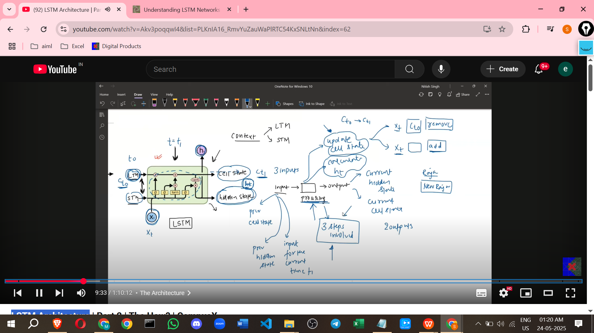

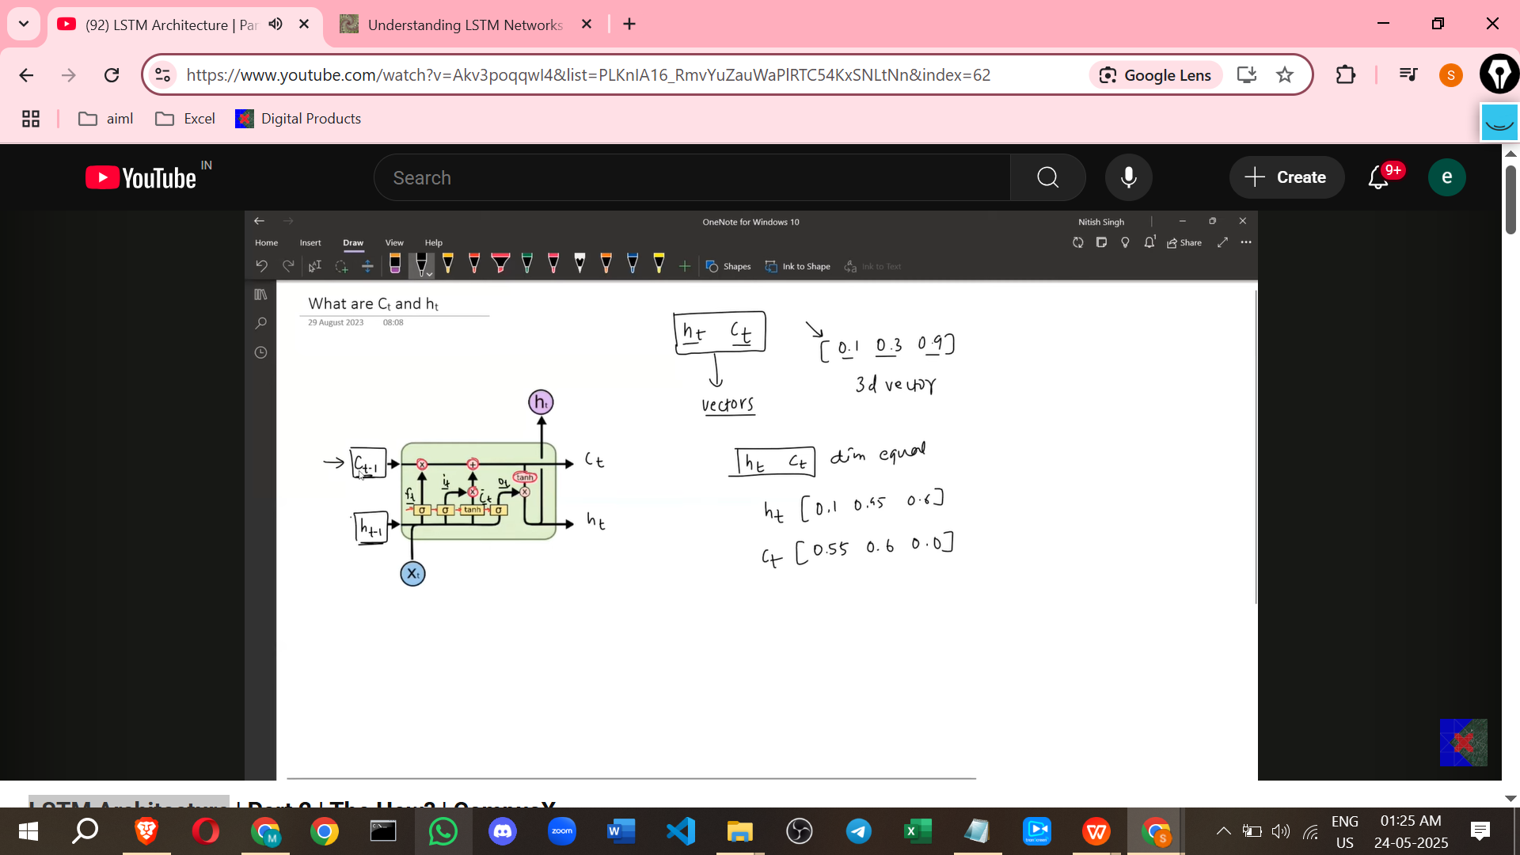

* **Mathematical Components:**
  + **Cell State (Ct) and Hidden State (Ht):** Mathematically, these are **Vectors** (collections of numbers). They are 3-dimensional vectors in the example discussed. The dimension (number of nodes in the neural network layers) is flexible and decided by the user (e.g., 4 in the example). The dimension of the cell state and hidden state vectors **must be the same**.

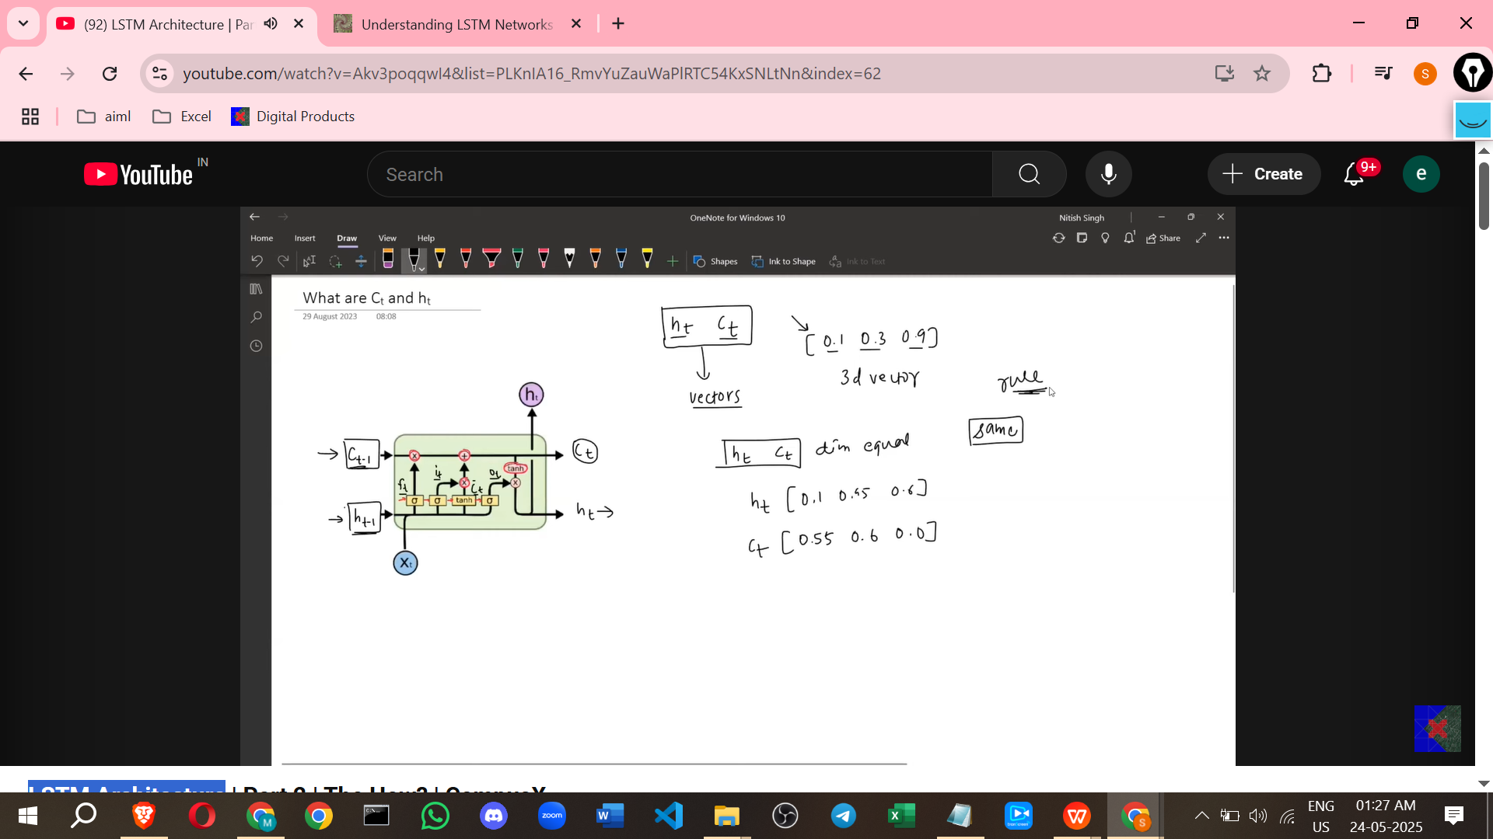

* + **Input (Xt):** Mathematically, this is also a **Vector**. It represents the input for the current time step, such as a word converted into a vector using techniques like one-hot encoding or TF-IDF. The dimension of the input vector (Xt) can be **different** from the dimension of the cell state and hidden state vectors. In the example, Xt is a 4-dimensional vector.
  + 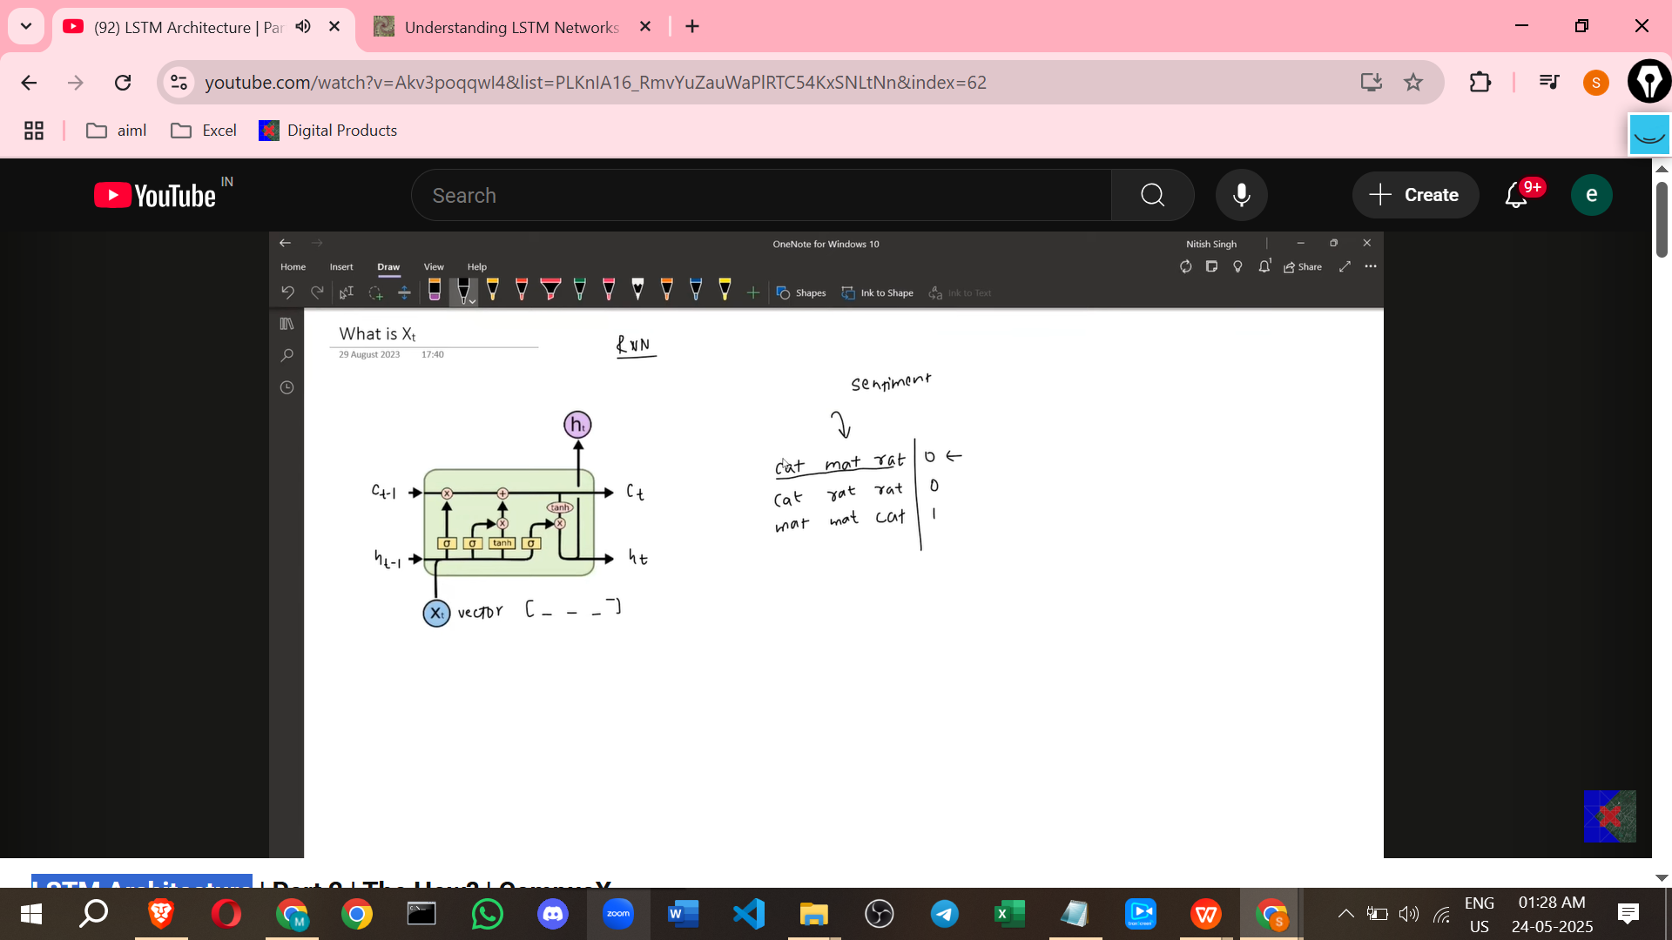

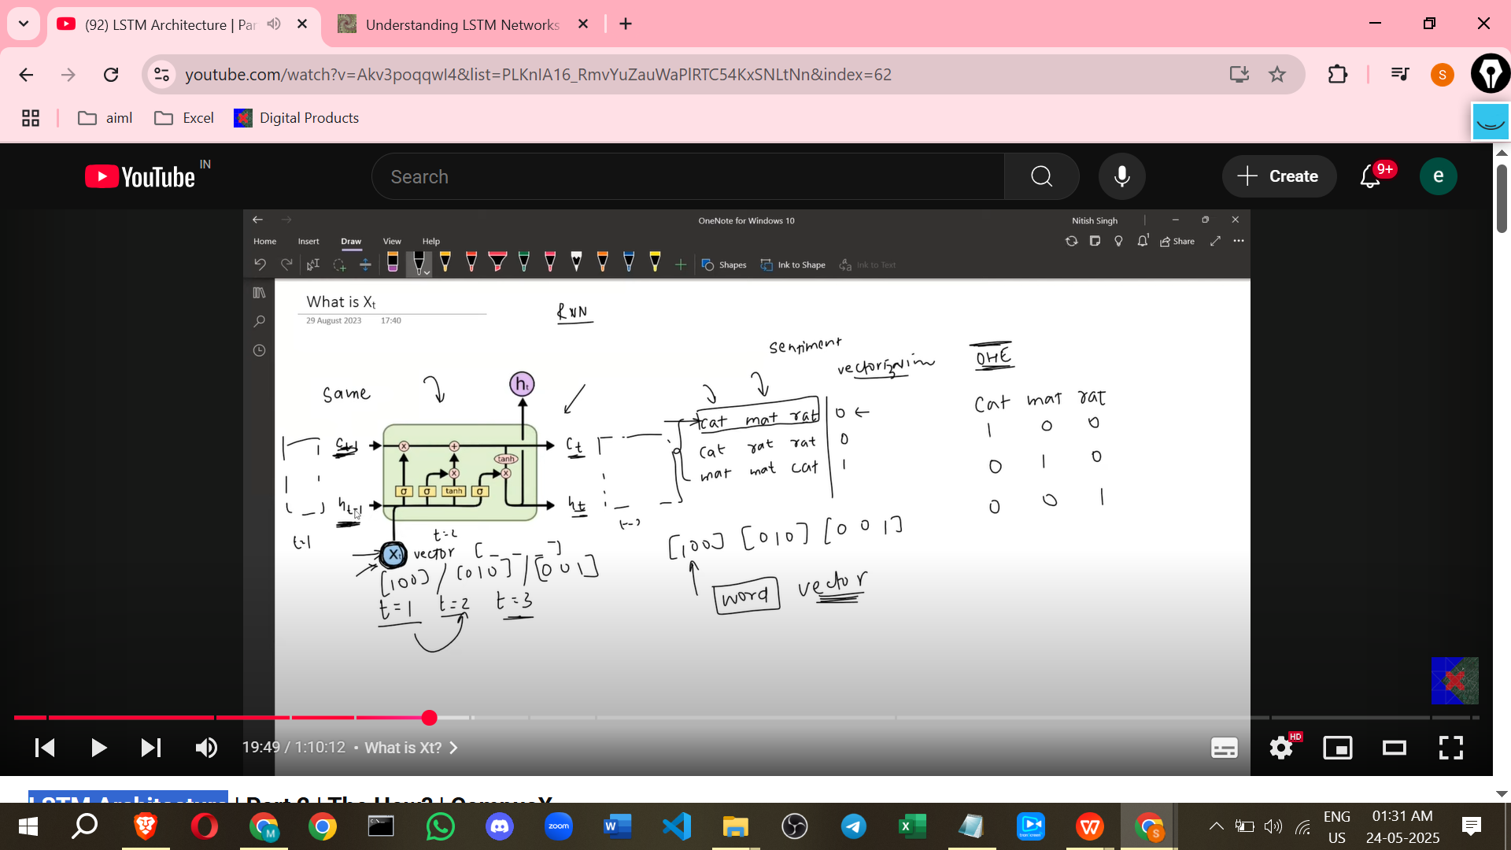

* + **Gate Outputs (Ft, It, Ct_bar, Ot):** These are also **Vectors**.

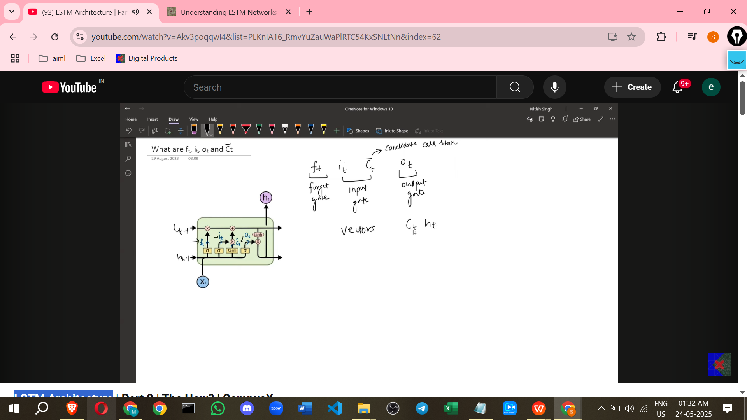

* + - Ft (Forget Gate output).
    - It (Input Gate output).
    - Ct_bar (Candidate Cell State). This is also called the "Candidate".
    - Ot (Output Gate output).
    - Ft, It, Ct_bar, and Ot are all **3-dimensional vectors** in the example, matching the dimension of the cell state and hidden state vectors. All six vectors discussed (Cell State, Hidden State, Ft, It, Ct_bar, Ot) have the **same shape/number of dimensions**.
  + **Mathematical Operations:**
    - **Red Circles:** Represent **Point-wise Operations**.

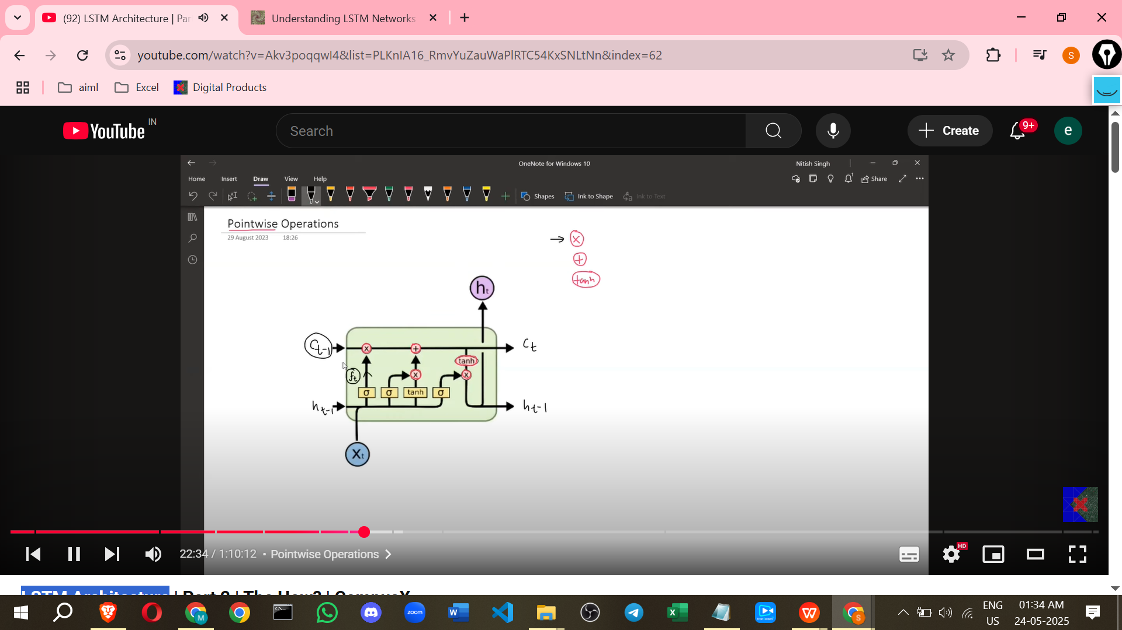

* + - * **Point-wise Multiplication:** Takes two vectors of the same dimension and multiplies their corresponding elements. Example: * = [4*1, 5*2, 6*3] =.
      * **Point-wise Addition:** Takes two vectors of the same dimension and adds their corresponding elements. Example: + = [4+1, 5+2, 6+3] =.

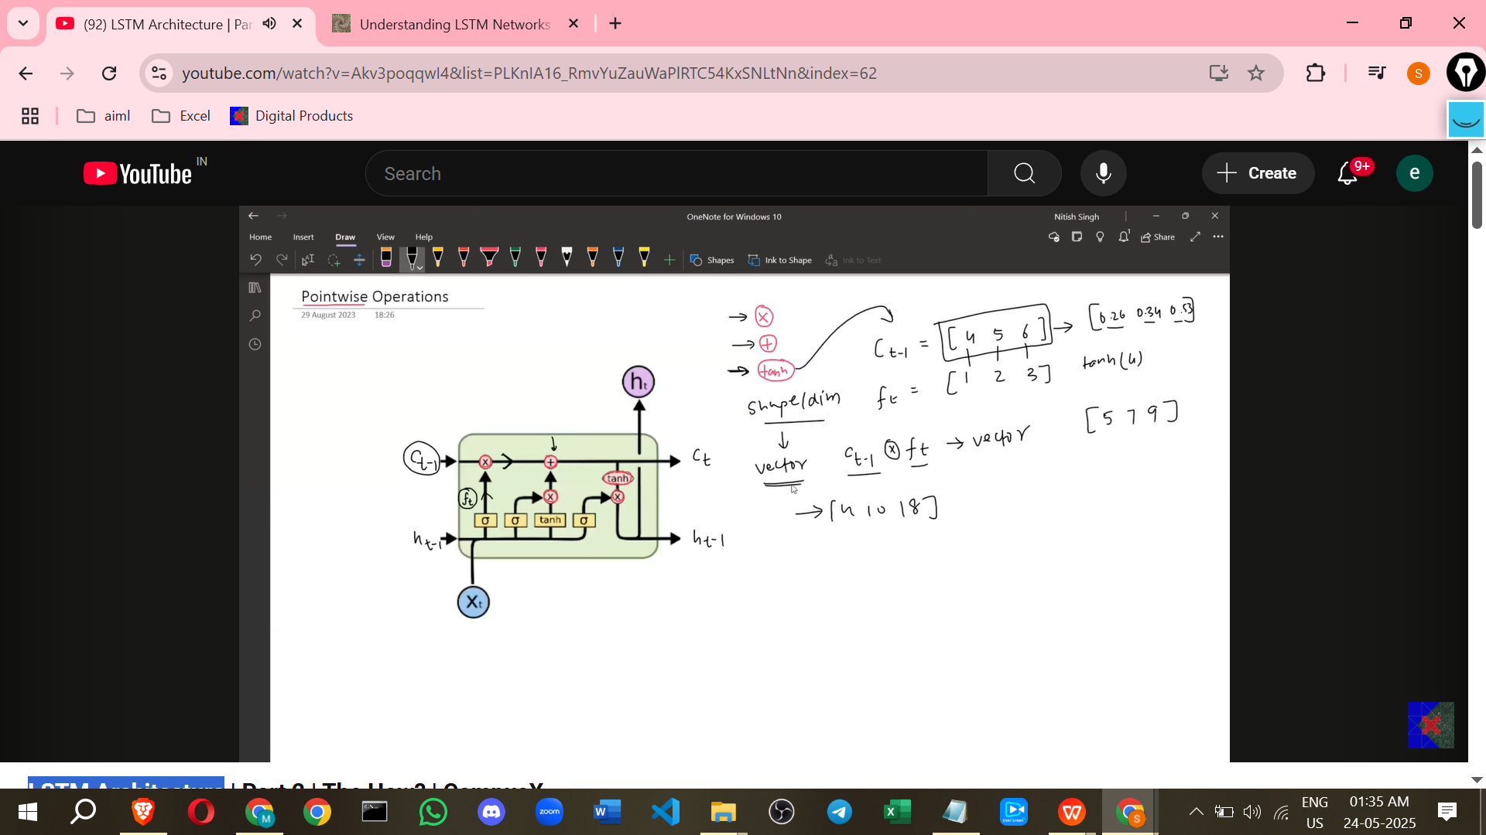

* + - **Yellow Rectangles:** Represent **Neural Network Layers**.

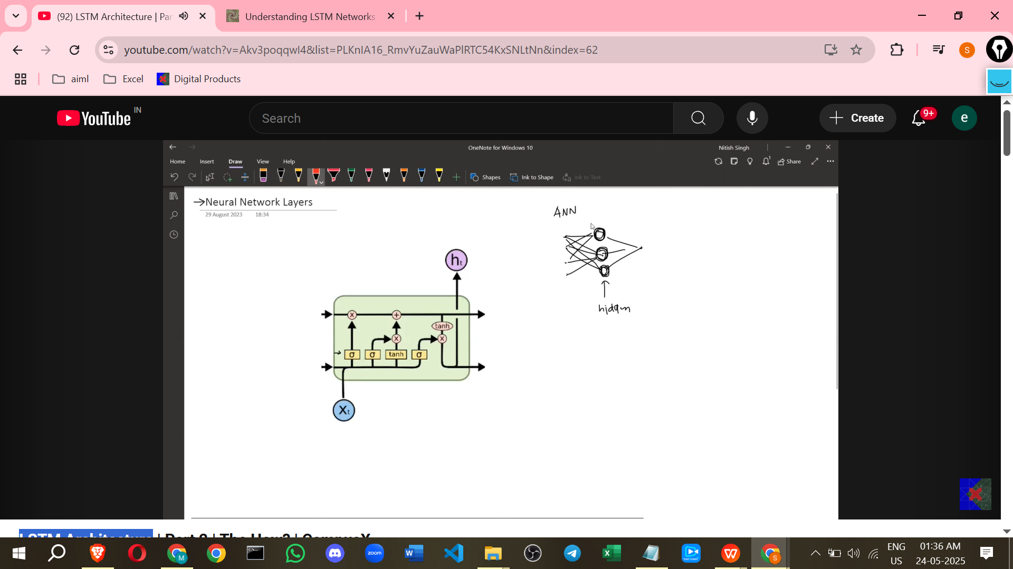

* + - * These are typically simple layers like a dense layer with an activation function.
      * They have an activation function (e.g., Sigmoid or Tanh) applied element-wise to the output.
      * They receive a **concatenation** of the previous hidden state (Ht-1) and the current input (Xt) as input.
      * The number of units or nodes in these layers is **flexible and decided by the user**. In the example, this is 3 units.
      * A neural network layer mathematically performs: Activation(Weight Matrix * Concatenated Input + Bias).
      * The input to these layers is the concatenation of Ht-1 (3-dim) and Xt (4-dim), resulting in a 7-dimensional vector (3+4=7).
      * If the layer has 3 nodes, the weight matrix will have dimensions (Output Dim x Input Dim), e.g., 3x7.
      * The output of these layers will be a vector with the dimension equal to the number of nodes (e.g., 3-dim).

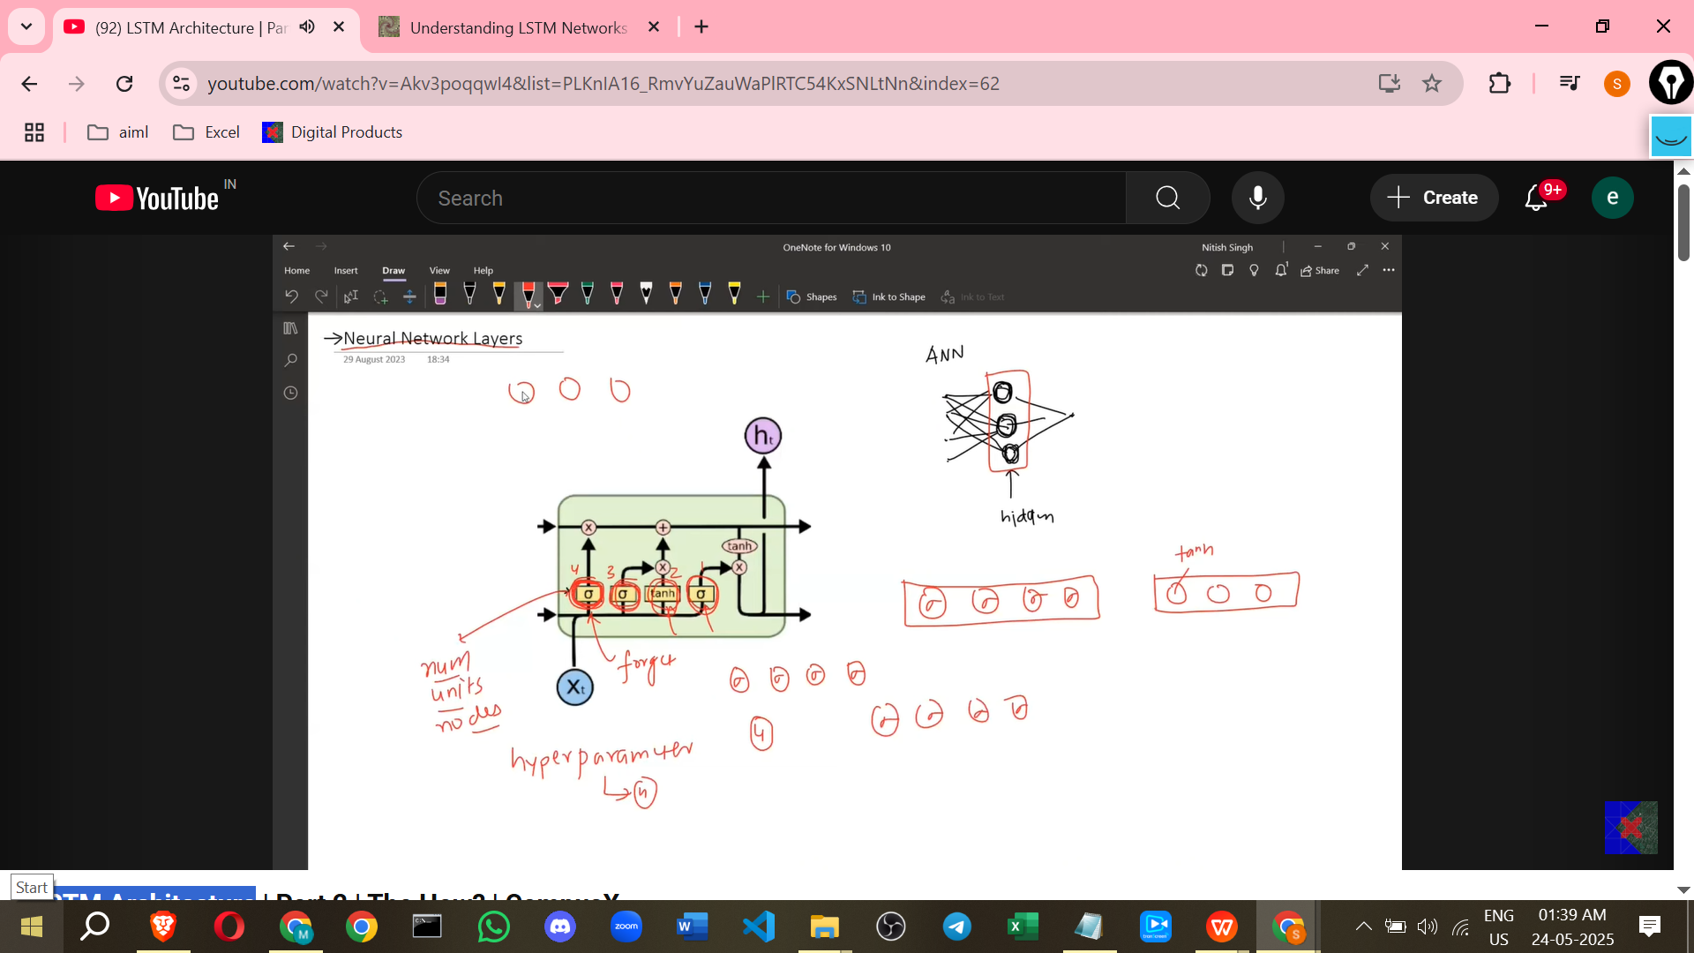

* **Individual Gates:**

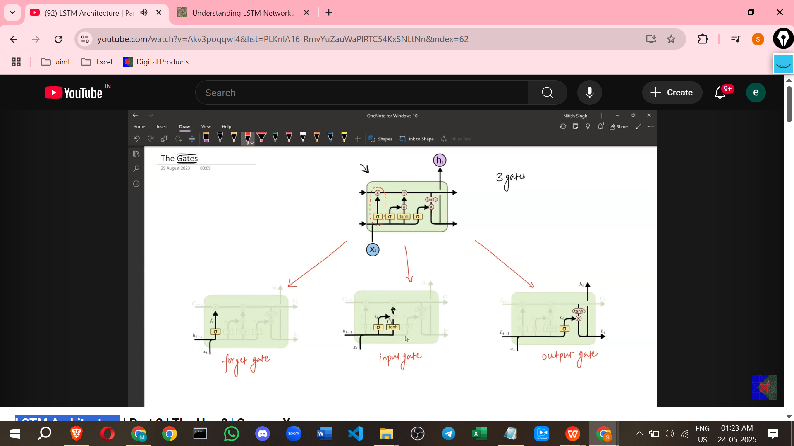

* + **Forget Gate (Ft):**

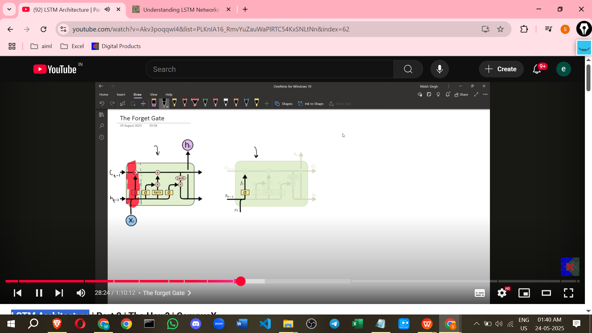

* + - * **Purpose:** To decide **what information to remove or forget** from the previous Cell State (Ct-1). It filters the long-term context based on the current input and previous hidden state.
    - **Location:** Highlighted part of the architecture responsible for removal from the cell state line.
    - **Inputs:** Previous Hidden State (Ht-1) and Current Input (Xt).
    - **Internal Structure:** A neural network layer with a **Sigmoid** activation function. The number of nodes matches the cell state/hidden state dimension (e.g., 3).

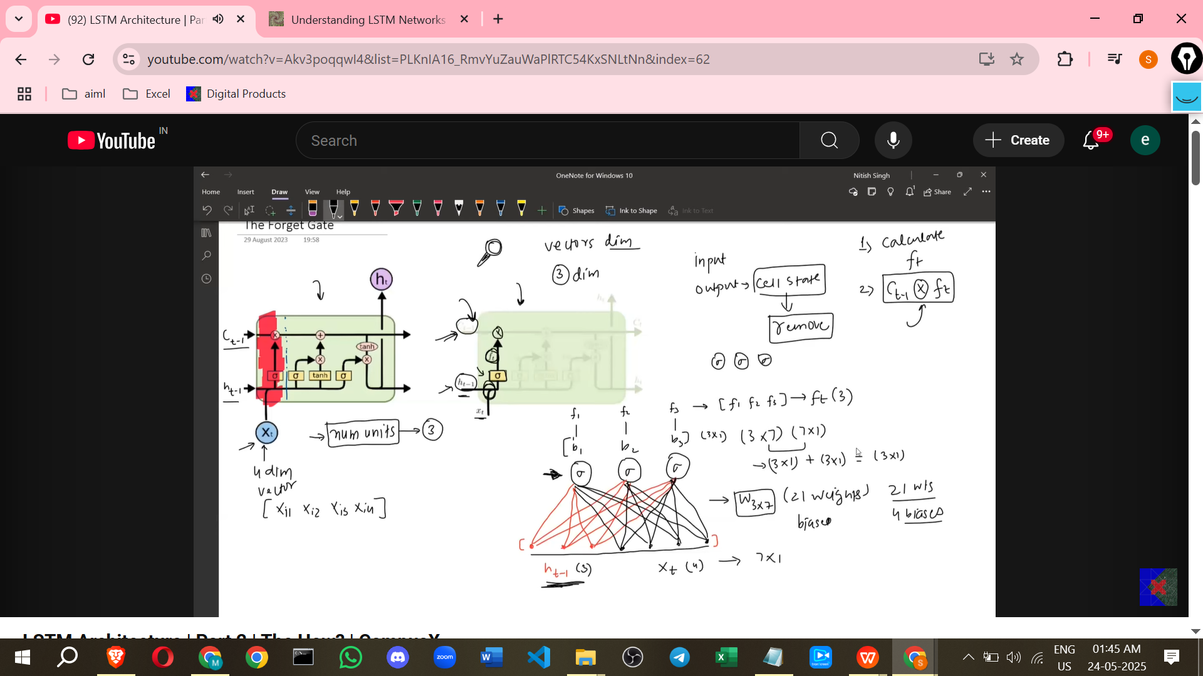

* + - **Process:**
      * It takes Ht-1 and Xt, concatenates them, and passes them through the sigmoid-activated neural network layer.
      * The output of this layer is the Forget Gate vector (Ft).
      * **Equation:** Ft = Sigmoid(Wf * [Ht-1, Xt] + Bf) where [Ht-1, Xt] is the concatenation of Ht-1 and Xt, Wf is the weight matrix, and Bf is the bias vector.

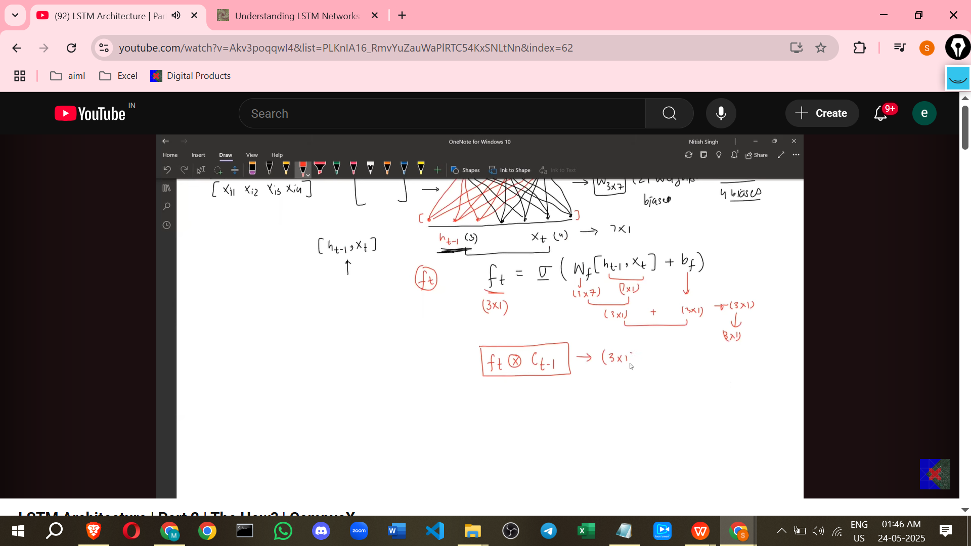

* + - **Modification of Cell State:** The Forget Gate vector (Ft) performs a **point-wise multiplication** with the Previous Cell State (Ct-1). This is the "removal" operation.

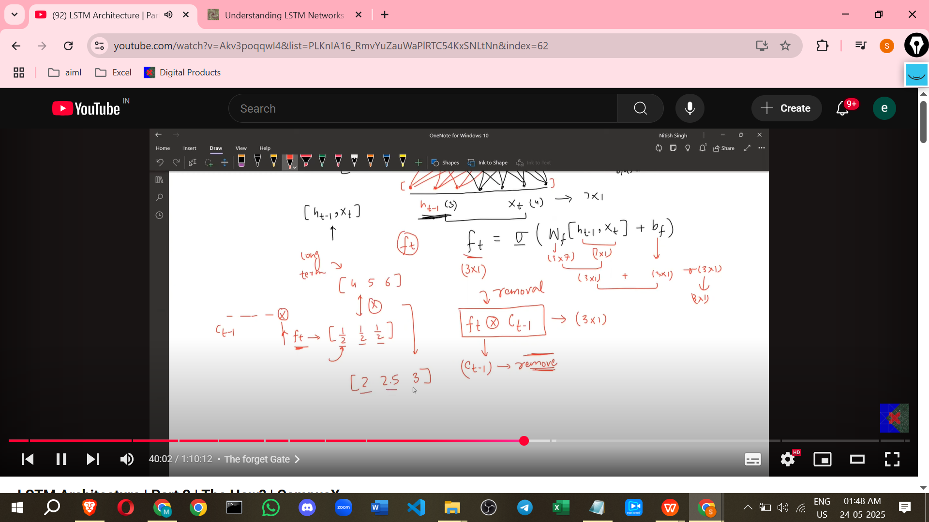

* + - **Significance:** The values in the Forget Gate vector (Ft) are between 0 and 1 due to the Sigmoid activation.
      * If an element in Ft is 0, the corresponding information in Ct-1 is completely removed.
      * If an element in Ft is 1, the corresponding information in Ct-1 is completely kept.
      * Values between 0 and 1 allow for partial forgetting.
    - **Analogy:** Acts like a **gate** that decides how much information from Ct-1 is allowed to pass through.
    - FT decide from xt and xt-1

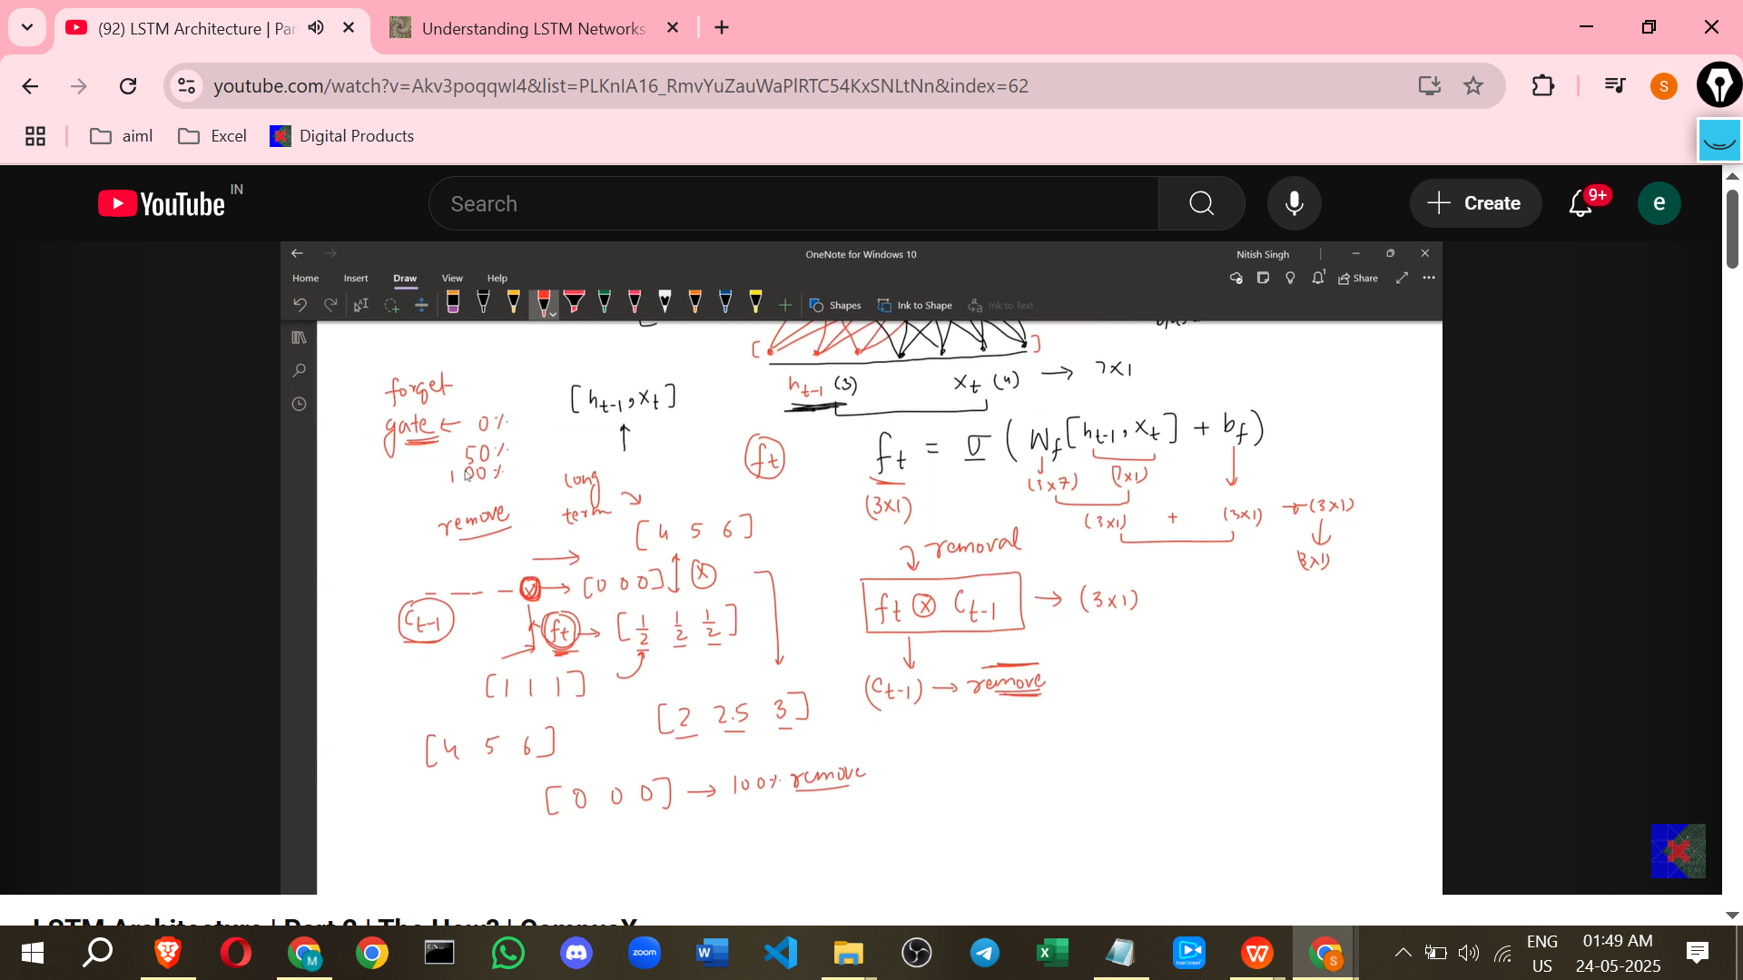

* + **Input Gate (It) & Candidate Cell State (Ct_bar):  
    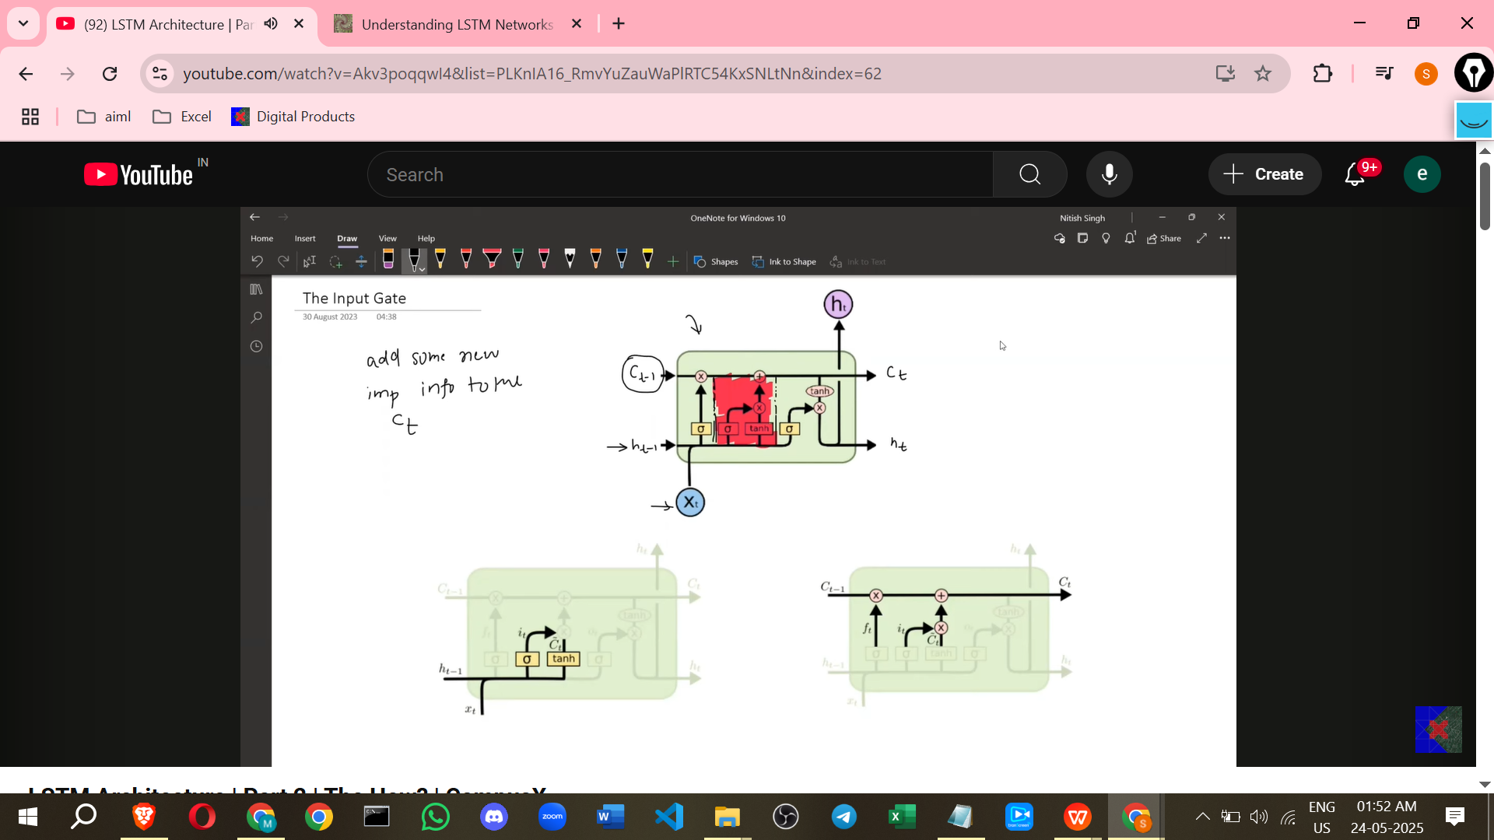**
    - **Purpose:** To decide **what new information to add** to the Cell State. It finds and prepares new candidate values based on the current input and previous hidden state.
    - **Location:** The part of the architecture where new information is added to the cell state line.
    - **Inputs:** Previous Hidden State (Ht-1) and Current Input (Xt).

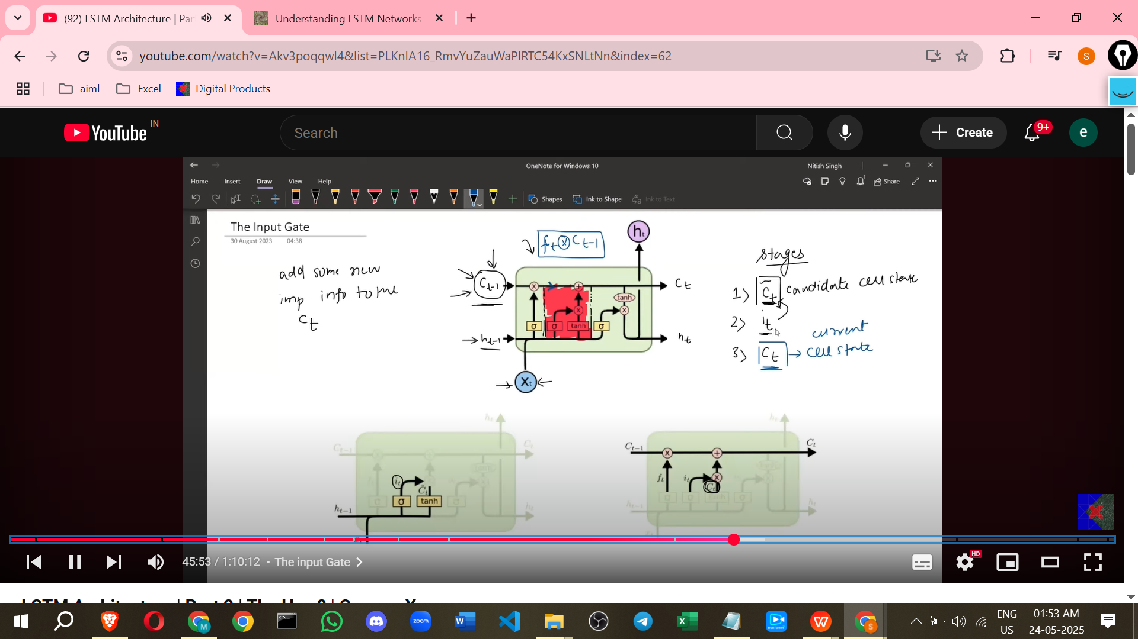

* + - **Internal Structure:** This involves **two separate neural network layers**. Both take the concatenation of Ht-1 and Xt as input. The number of nodes in both layers matches the cell state/hidden state dimension (e.g., 3).
      * **Layer 1 (Candidate Cell State - Ct_bar):** Uses a **Tanh** activation function. Its output is the **Candidate Cell State vector (Ct_bar)**.

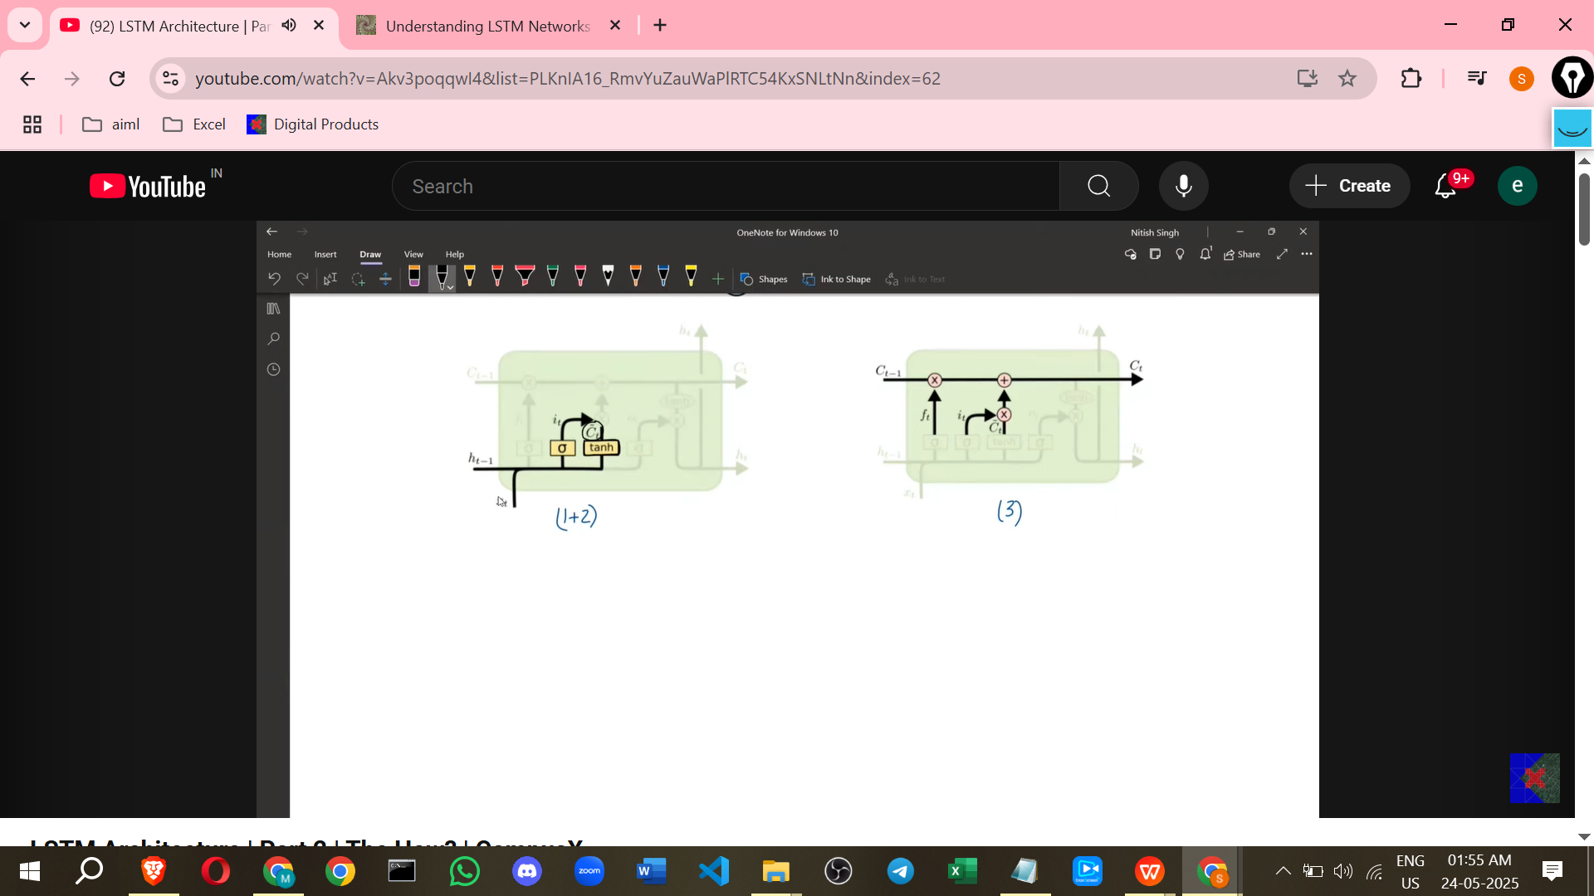

* + - * + **Equation:** Ct_bar = Tanh(Wc * [Ht-1, Xt] + Bc) where Wc is the weight matrix and Bc is the bias vector.

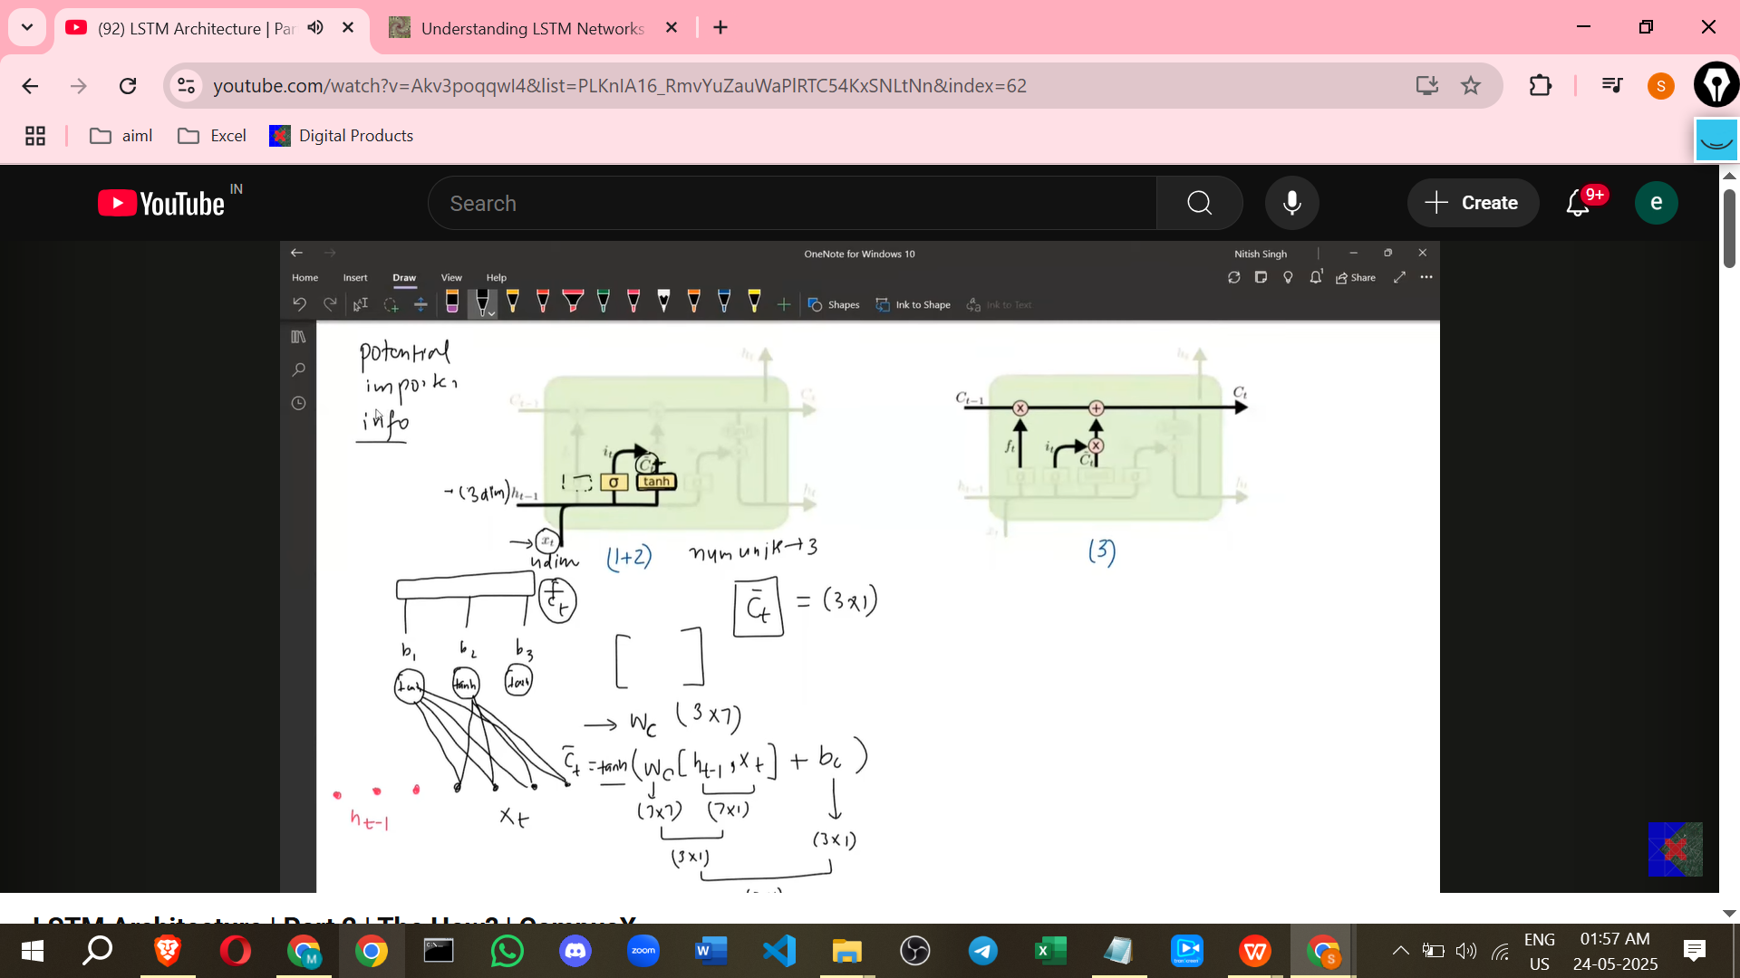

* + - * **Layer 2 (Input Gate - It):** Uses a **Sigmoid** activation function. Its output is the **Input Gate vector (It)**.
        + **Equation:** It = Sigmoid(Wi * [Ht-1, Xt] + Bi) where Wi is the weight matrix and Bi is the bias vector.

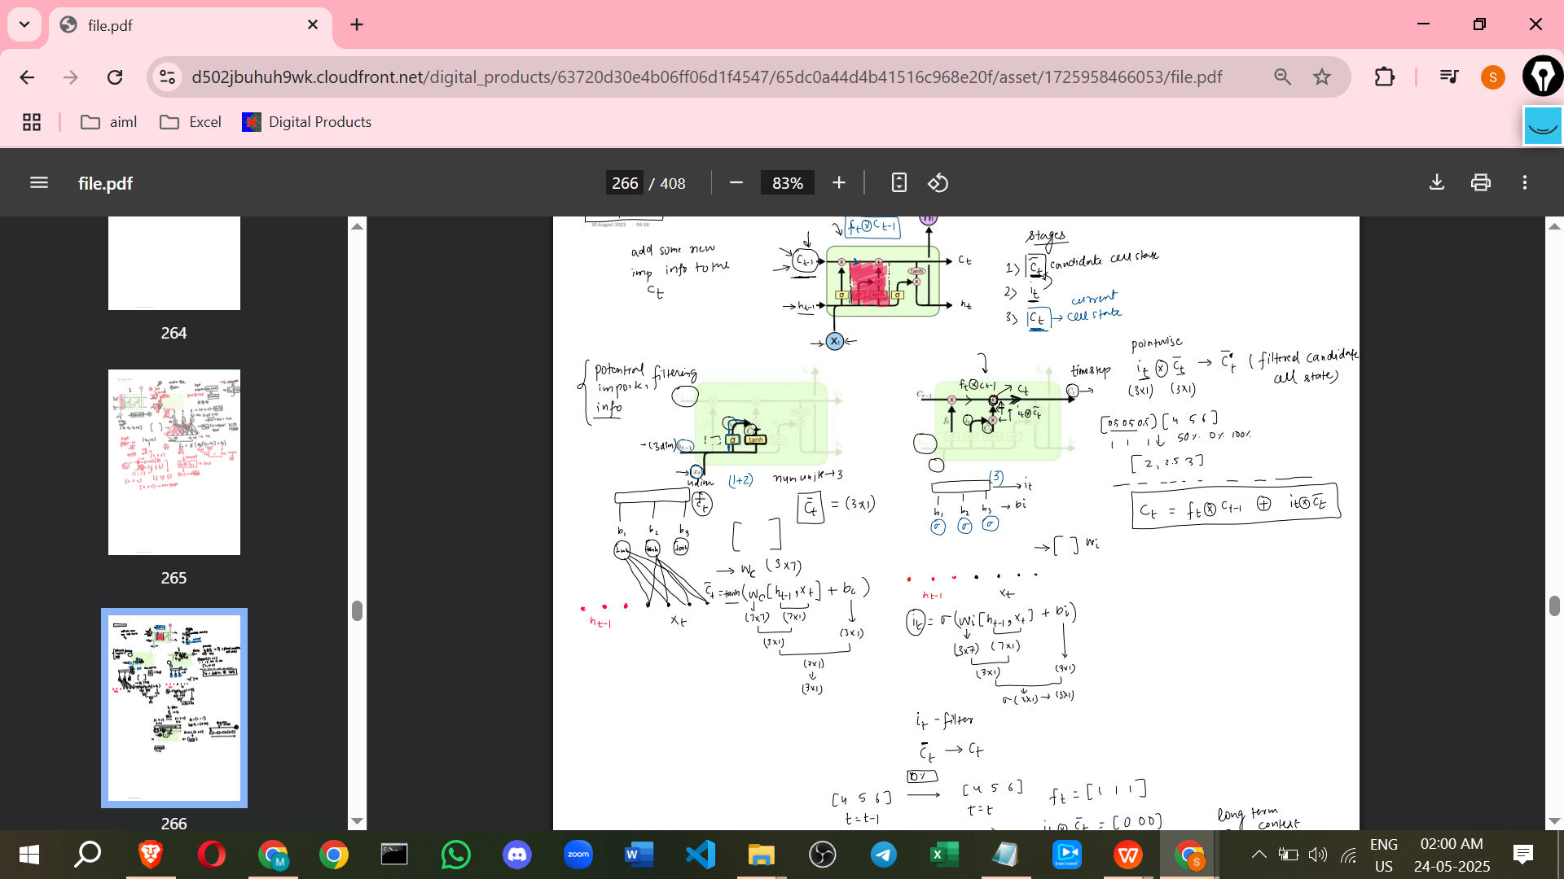

* + - **Process:**
      * The Tanh layer (Ct_bar) generates a vector of new candidate values, ranging from -1 to 1.
      * The Sigmoid layer (It) generates a vector acting as a **filter**, values ranging from 0 to 1. This filter decides how much of the Ct_bar information is important to keep.
      * These two vectors (It and Ct_bar) are combined using **point-wise multiplication** (It * Ct_bar). This is referred to as the "filtered candidate".
  + **Updating the Cell State (Ct):**
    - **Purpose:** To produce the final Cell State for the current time step (Ct).
    - **Process:** The result of the Forget Gate operation (Ft * Ct-1) is **point-wise added** to the result of the Input Gate operations (It * Ct_bar).
    - **Equation:** Ct = (Ft * Ct-1) + (It * Ct_bar).
    - **Significance:** This additive interaction is crucial.
      * It allows information from previous cell states (Ct-1) to pass through relatively unchanged if the Forget Gate allows it (Ft values are close to 1). This helps **mitigate the vanishing gradient problem** that affects RNNs by allowing information to flow across many time steps without degradation.
      * It allows new information (Ct_bar) to be incorporated into the cell state only if the Input Gate deems it important (It values are close to 1).
      * If Ft is 1 and It is 0, the cell state effectively carries forward the previous state without adding new information, preventing loss of old, important context.

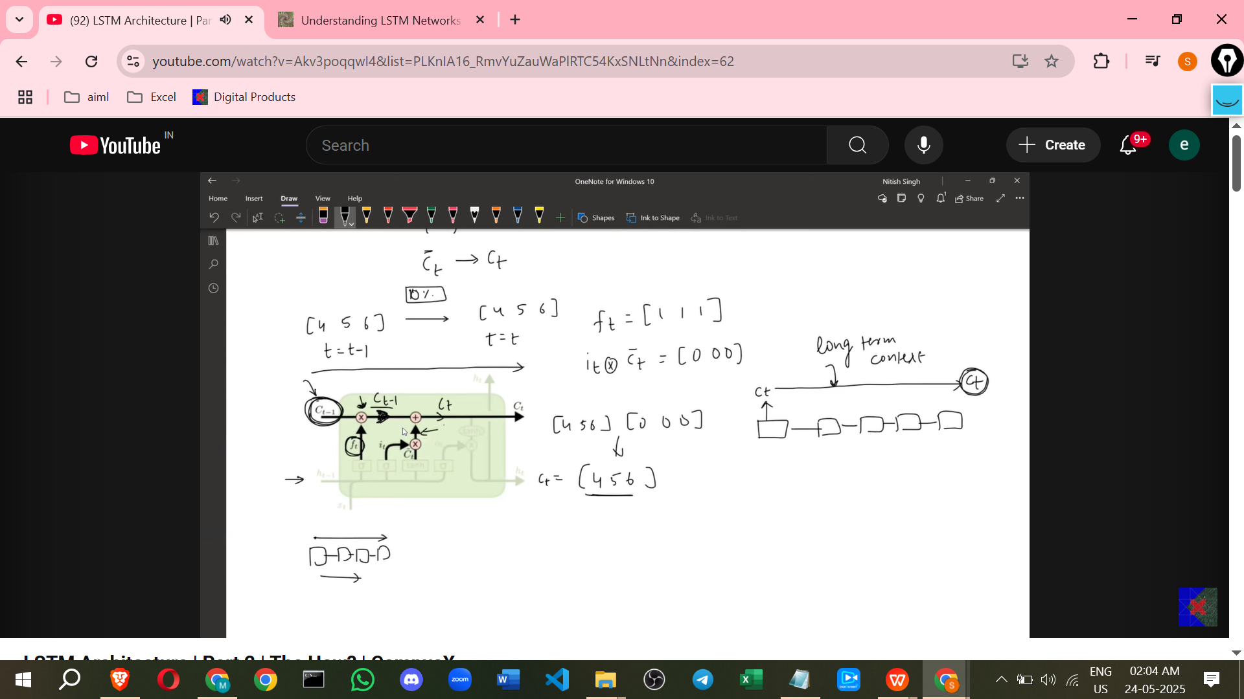

* + **Output Gate (Ot) & Hidden State (Ht):**

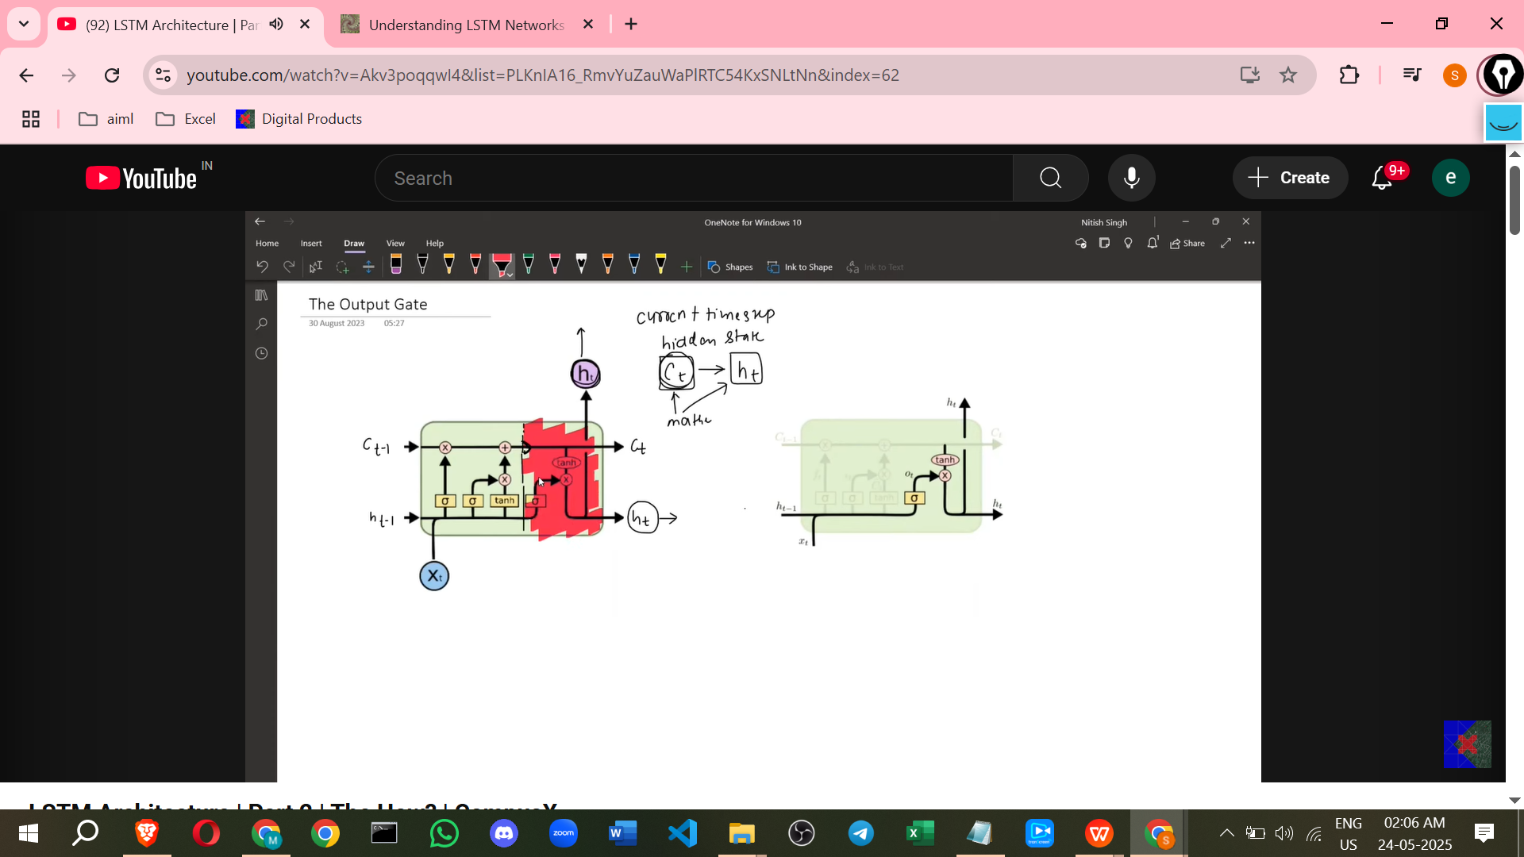

* + - **Purpose:** To decide the **output** for the current time step and the **Hidden State** to be passed to the next time step. The output/hidden state is derived from the Current Cell State (Ct).
    - **Location:** The right side of the architecture, showing how Ct is used to generate Ht.
    - **Inputs:** Previous Hidden State (Ht-1) and Current Input (Xt), and the Current Cell State (Ct).
    - **Internal Structure:**
      * First, the Current Cell State (Ct) is passed through a **Tanh** activation function.
      * Separately, there's a neural network layer with a **Sigmoid** activation function. This layer takes the concatenation of Ht-1 and Xt as input. The number of nodes matches the cell state/hidden state dimension (e.g., 3). Its output is the **Output Gate vector (Ot)**.
        + **Equation:** Ot = Sigmoid(Wo * [Ht-1, Xt] + Bo) where Wo is the weight matrix and Bo is the bias vector.

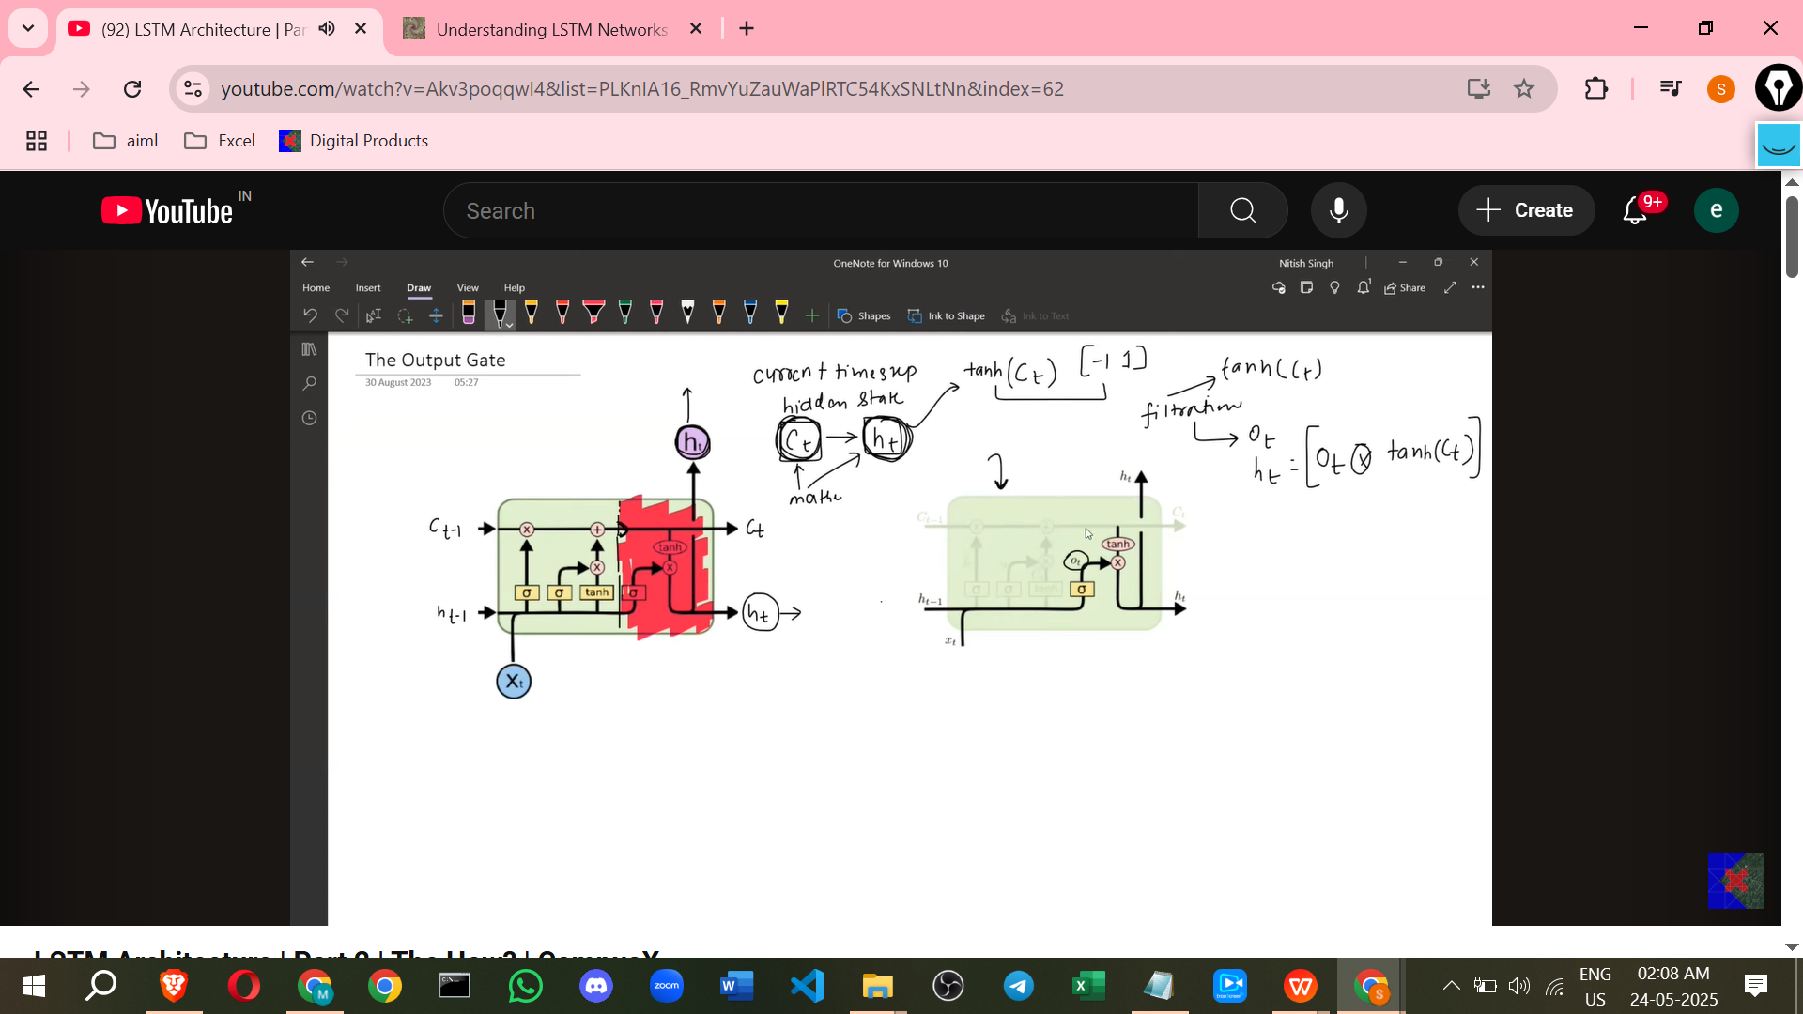

* + - **Process:** The Tanh-activated Cell State (Tanh(Ct)) is combined with the Output Gate vector (Ot) using **point-wise multiplication**.
    - **Equation:** Ht = Ot * Tanh(Ct).
    - **Significance:** The Tanh(Ct) scales the cell state values between -1 and 1. The Output Gate (Ot), with values between 0 and 1 due to Sigmoid, acts as a **filter** on this scaled cell state, determining which parts of the cell state are exposed as the output (Ht).
    - 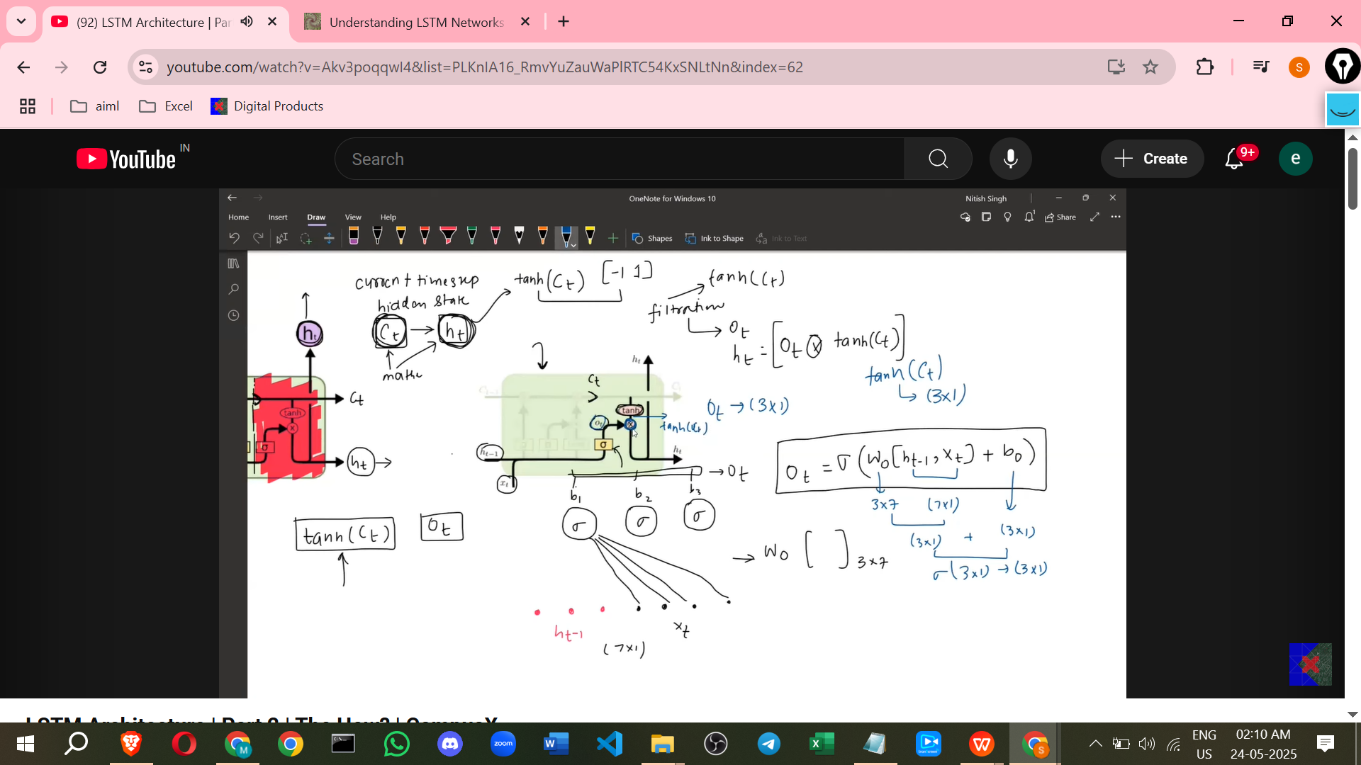

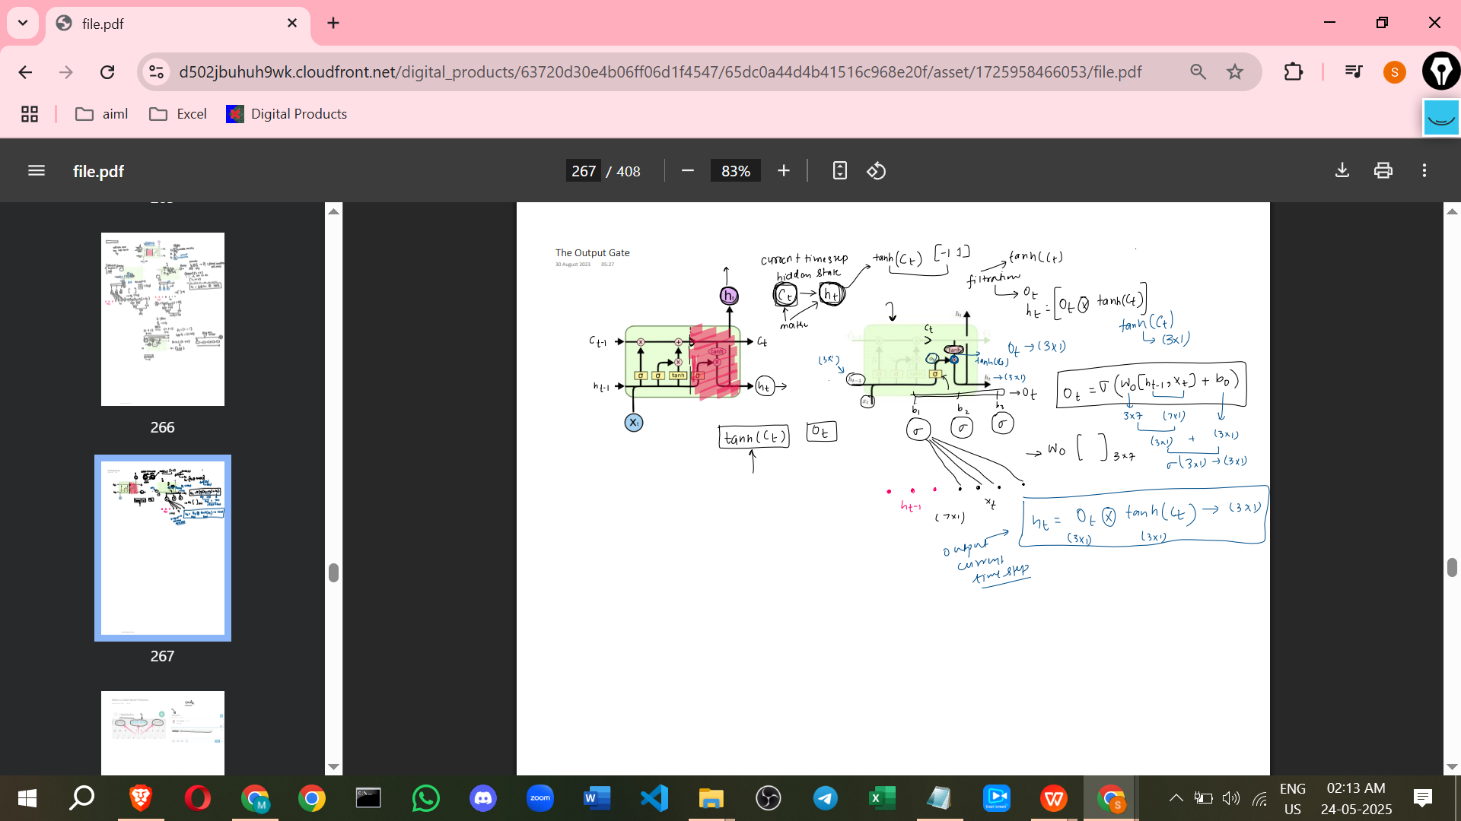

* **Summary of Main Gates and Equations:**
  + **Forget Gate:** Ft = Sigmoid(Wf * [Ht-1, Xt] + Bf)
  + **Input Gate:** It = Sigmoid(Wi * [Ht-1, Xt] + Bi)
  + **Candidate Cell State:** Ct_bar = Tanh(Wc * [Ht-1, Xt] + Bc)
  + **Update Cell State:** Ct = (Ft * Ct-1) + (It * Ct_bar)
  + **Output Gate:** Ot = Sigmoid(Wo * [Ht-1, Xt] + Bo)
  + **Final Hidden State/Output:** Ht = Ot * Tanh(Ct)
* **Benefit (Added point):** As highlighted when discussing the Cell State update, the key benefit of LSTMs over standard RNNs is their ability to learn **long-term dependencies**. The gate mechanisms, particularly the additive interaction in the Cell State update (Ct = (Ft * Ct-1) + (It * Ct_bar)), allow information to flow across many time steps largely unimpeded, effectively combating the vanishing gradient problem that limits RNNs' ability to connect information across long sequences. This is not explicitly stated as a *single* benefit point in the provided text, but the mechanism and comparison to RNN issues are explained.
* **Visualisation (Added point):** The transcript mentions using diagrams and an animation to visualise the architecture and how the cell works. While the text describes the steps, seeing these visualisations is typically crucial for grasping the flow of information through the gates and operations. This is not from the source text itself, but implied by the description of the video content.

LSTM WORK ANIMATIONS

[LSTM Animated Visualization](https://youtu.be/-qpXVJnRC1w?si=OoI7Fz_S5VlV7HAv)

===========================================

# **LSTM | Part 3 | Next Word Predictor Using**

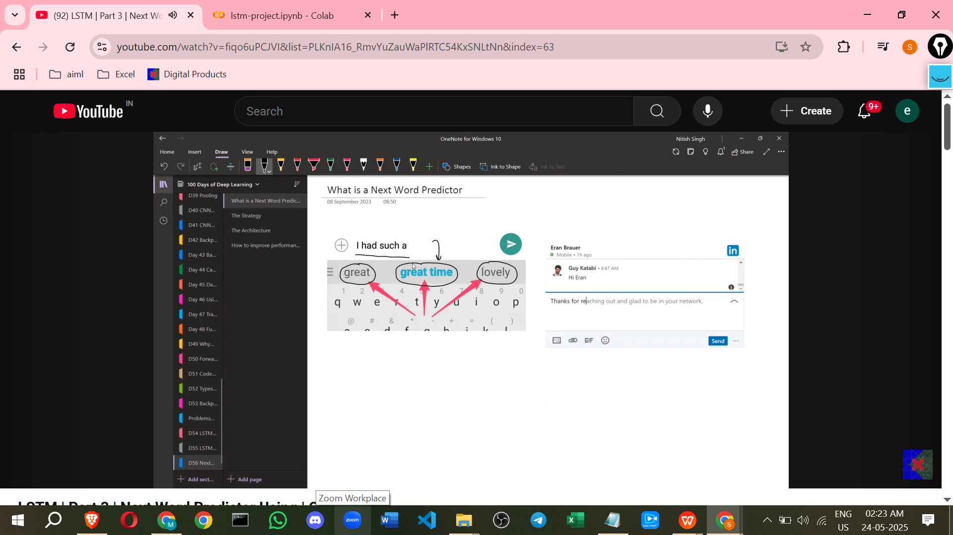

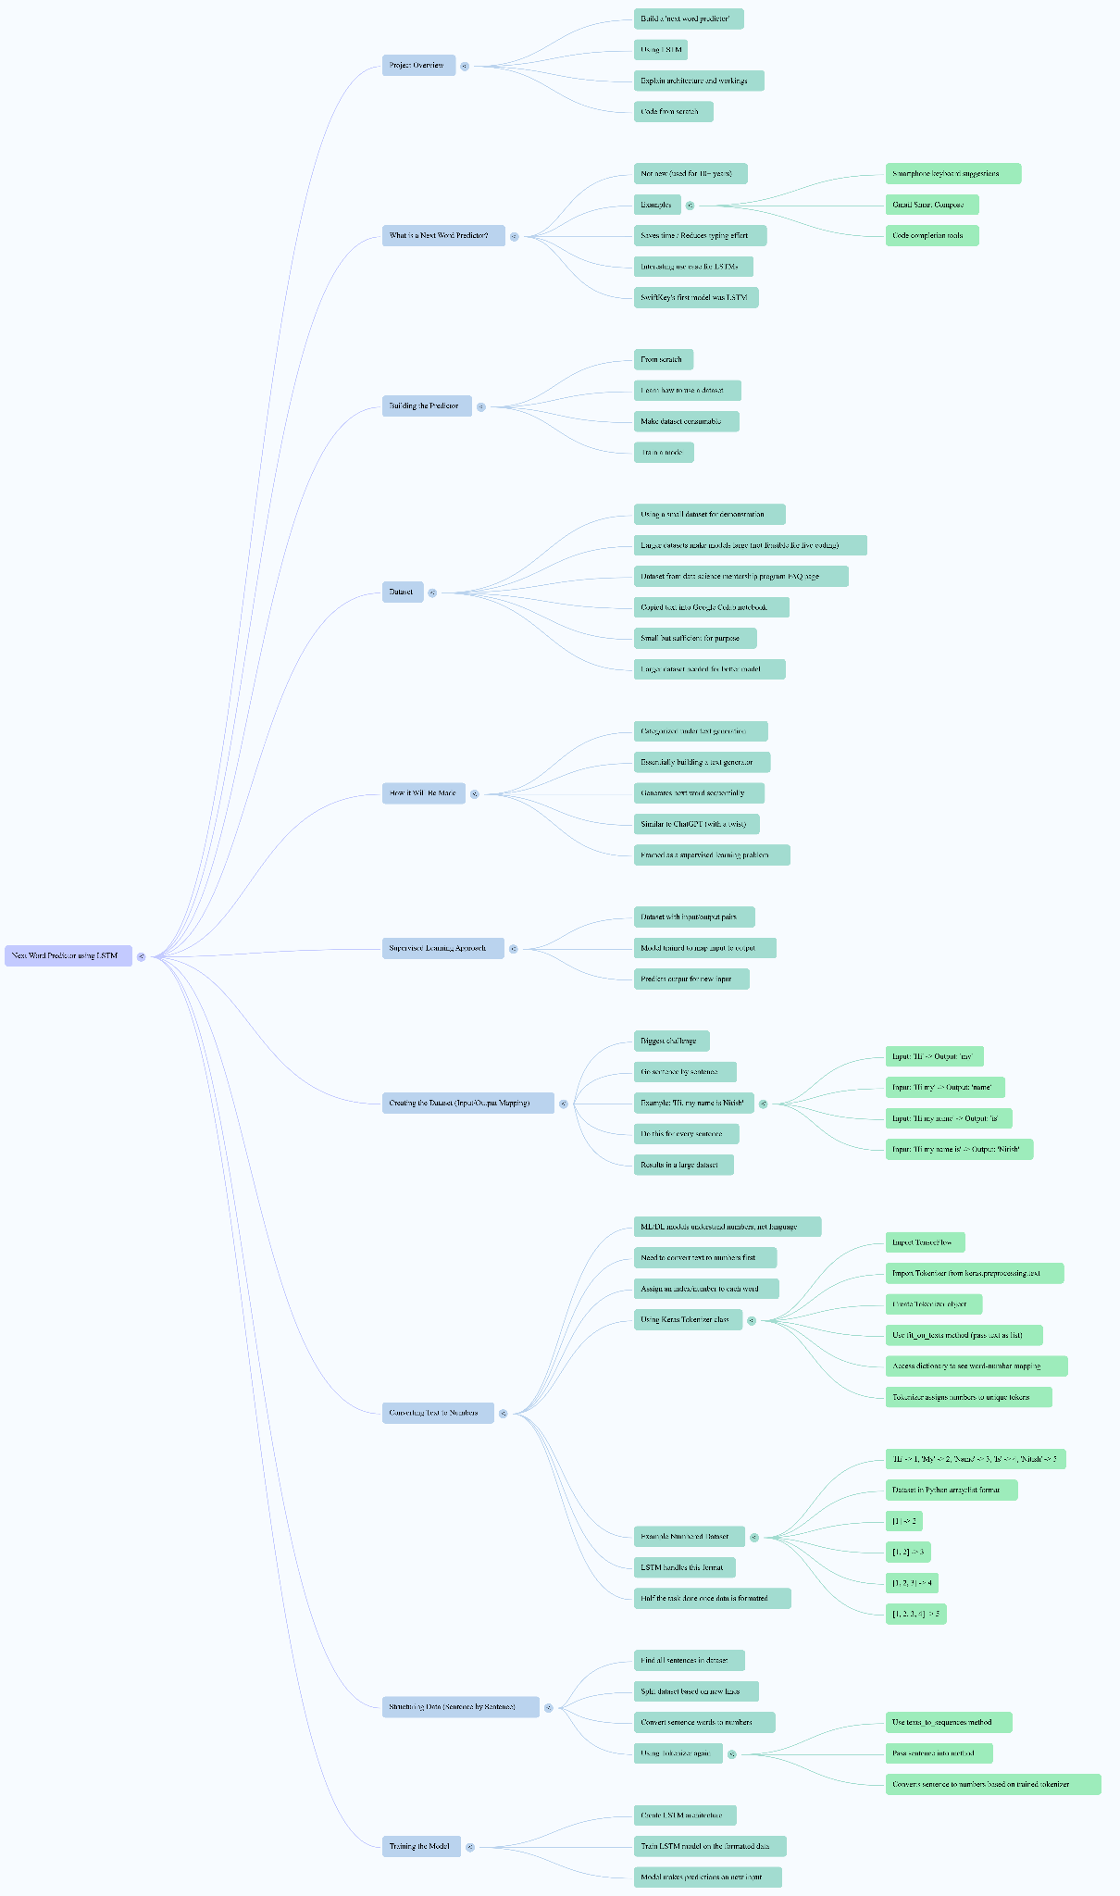

the concept of building a '**next word predictor**' using LSTM, drawing directly from the provided source material and adding some clarifying points.

Here are notes on the concept:

[Copy of lstm-project.ipynb](https://colab.research.google.com/drive/1f552_XYv9N6lJ5lSYKQ2pSu0f3pZQQn4?usp=sharing)

**Project Goal:**

* The project is to build a 'next word predictor' using LSTM.
* It will involve understanding what a next word predictor is, using a dataset, building the predictor with LSTM, explaining the architecture and workings, and coding from scratch.

**What is a Next Word Predictor?**

* It is not a new concept; it has been used for about 10 years since smartphones became common.
* Examples include smartphone keyboard suggestions, Gmail's 'Smart Compose', and code completion tools.
* It is a feature that suggests the next word as you type.

**Why are they Important?**

* They are very important in today's internet age.
* They save time or reduce typing effort.

**Role of LSTM:**

* Next word prediction is a use case where LSTMs are frequently used.
* SwiftKey's first model for this purpose was LSTM, although they now use more complex models.
* The video will build a next word predictor from scratch using LSTM.

**Overall Approach:**

* Building a next word predictor is categorised under **text generation**. Essentially, you are building a text generator.
* When given text, it generates the next word.
* The task can be framed as a **supervised learning problem**.
* In supervised learning, a model is trained on a dataset with input and corresponding output values. The model learns to predict an output for a given input.
* The goal is to convert the text generation task into a supervised learning task that can be handled.

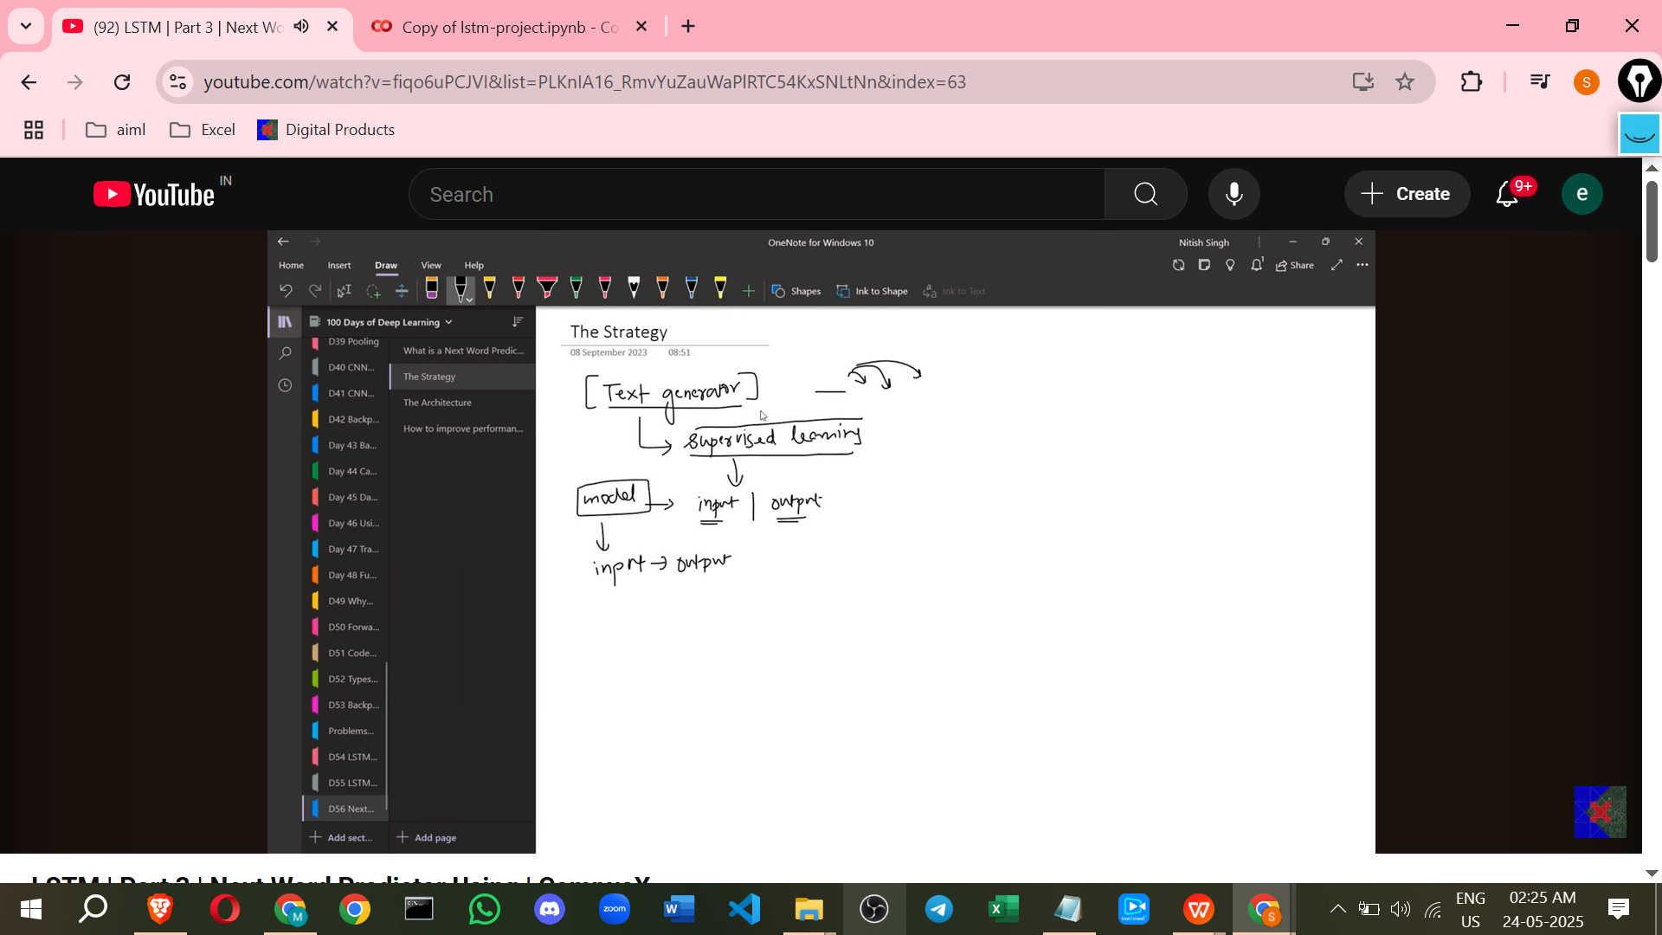

**Creating the Dataset for Supervised Learning:**

* The biggest challenge is creating a dataset where there is a mapping between input and output.
* The main concept is to create input and output pairs from sentences.
* For each sentence, you take it word by word.
* A sequence of words becomes the input, and the immediately following word becomes the output.
* **Example:** For the sentence "Hi, my name is Nitish":
  + Input: "Hi" -> Output: "my"
  + Input: "Hi my" -> Output: "name"
  + Input: "Hi my name" -> Output: "is"
  + Input: "Hi my name is" -> Output: "Nitish"
* This process is repeated for every sentence to create a large dataset of input/output pairs.
* An LSTM model will be trained on this dataset.

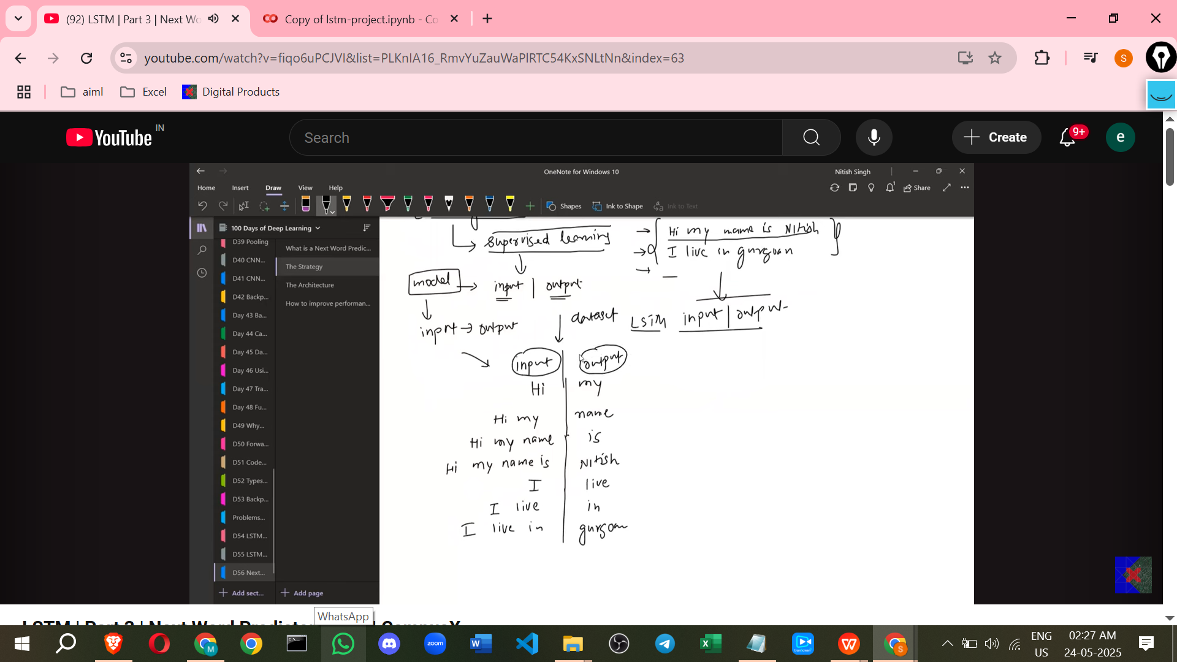

**Handling Text Data (Tokenization):**

* Machine learning and deep learning models do **not understand English words or any language directly**; they understand numbers.
* Therefore, the text must be **converted into numbers**.
* This involves assigning a unique number to each word.
* **Example:** "Hi" -> 1, "My" -> 2, "Name" -> 3, "Is" -> 4, "Nitish" -> 5.
* The dataset then consists of sequences of numbers as input and a single number as output.
  + Input: -> Output: 2
  + Input: -> Output: 3
  + Input: -> Output: 4
  + Input: -> Output: 5
* LSTMs can handle inputs in this numerical format.
* Converting data to this format is a crucial step.

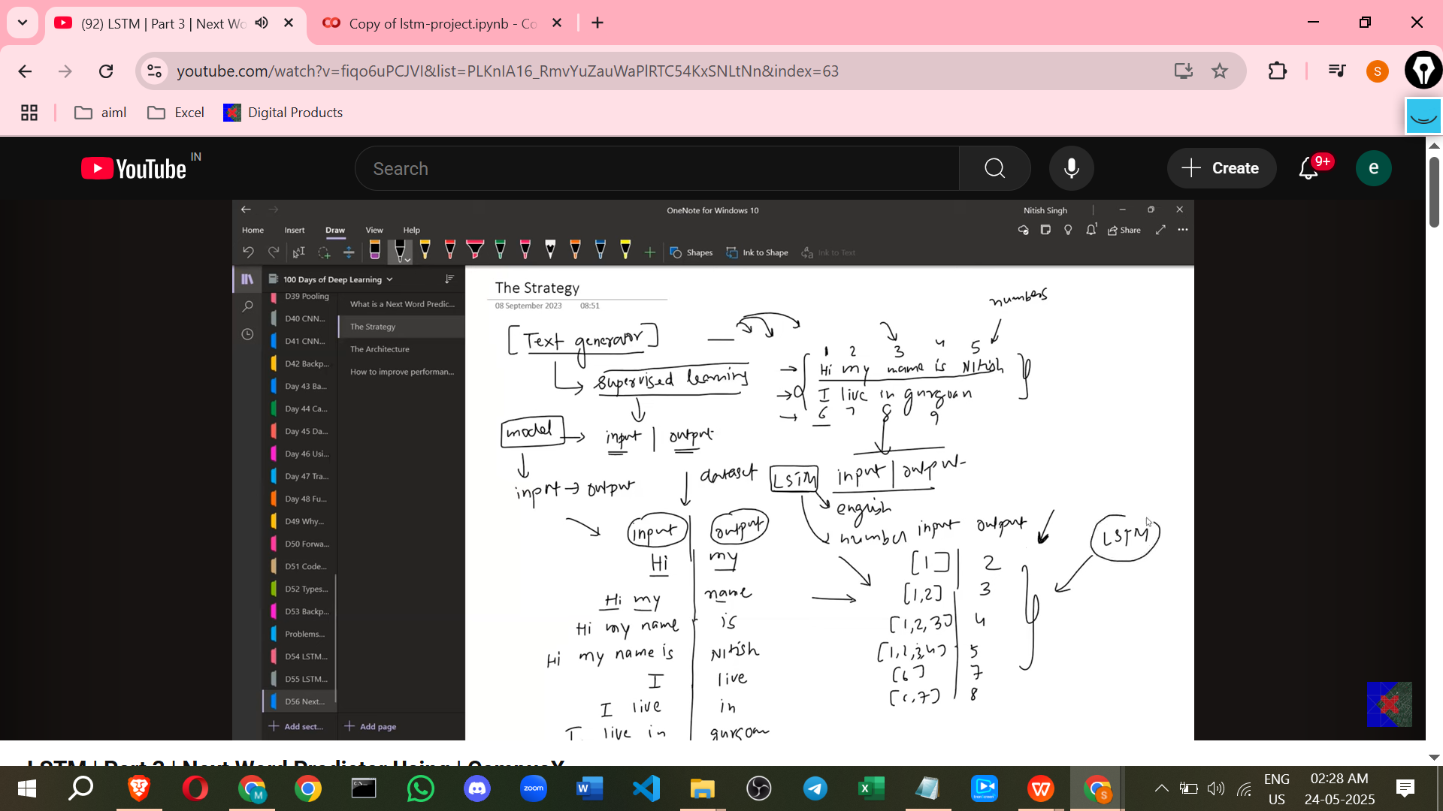

**Implementing Tokenization with Keras:**

* Assigning an index or number to each word is the first task.
* The **Tokenizer class in Keras** is used for this purpose.
* Necessary libraries like TensorFlow and Tokenizer from keras.preprocessing.text are imported.
* An object of the Tokenizer class is created (e.g., tokenizer).
* The tokenizer object has methods, including fit_on_texts.
* The entire text dataset (passed as a list of texts) is passed to fit_on_texts.
* Running fit_on_texts processes the text.
* After fitting, an attribute can be accessed to see a dictionary showing which number (token) has been assigned to every unique word.

**Preparing the Dataset for Sequence Creation:**

* The next task after tokenization is to create the input/output dataset structure.
* The first step for this is to **find all the sentences** in the dataset.
* A simple code can be used to split the dataset based on line changes (newlines) to get individual sentences.

**Converting Sentences to Sequences of Numbers:**

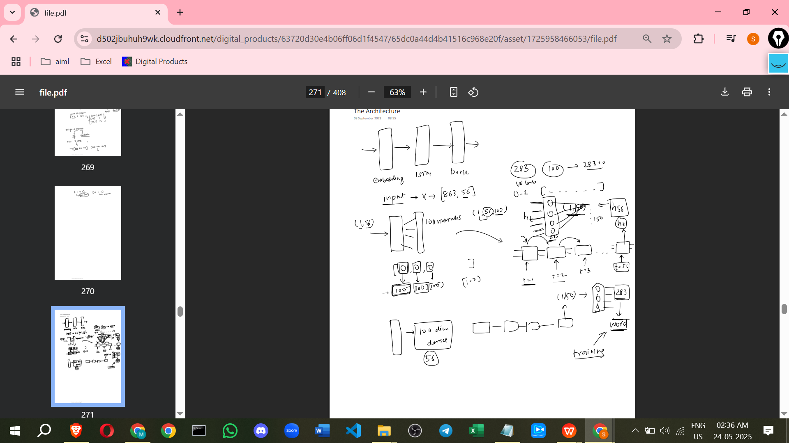

* Once sentences are identified, the words within them need to be converted into numbers.
* The **Tokenizer class** is used again for this.
* Another method, texts_to_sequences, is used.
* You pass the sentence (or a list of sentences/sequences) to texts_to_sequences.
* Based on the numbers assigned during the fit_on_texts step, this method converts the words in the sentence into a sequence of numbers.

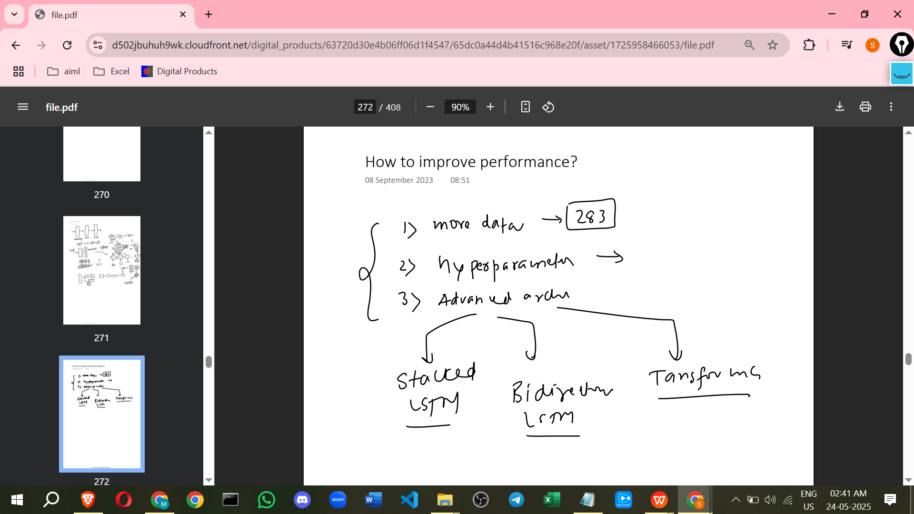

**Dataset Used:**

* For demonstration, a small dataset from a data science mentorship program's FAQ page is used.
* Larger datasets (like jokes or quotes from Kaggle) would create larger models, which are not feasible for a live coding demonstration.
* This small dataset is sufficient for demonstration, but a larger one would be needed for a better model.

**Additional Points to Enhance Understanding (Not from Sources):**

* **What is LSTM?** LSTM stands for Long Short-Term Memory. It is a type of Recurrent Neural Network (RNN) architecture. RNNs are designed to handle sequential data like text. LSTMs are particularly good at remembering information over longer sequences, which is important for understanding context in language and predicting the next word based on a sequence of previous words.
* **Vocabulary Size:** When the Keras Tokenizer fits on the text, it builds a vocabulary of all unique words it encounters. The size of this vocabulary determines how many unique numbers (tokens) are assigned. Words not in the vocabulary might be handled differently (e.g., ignored or assigned a special 'unknown' token), though the source doesn't detail this.
* **Input/Output Structure Nuance:** The example dataset creation shows inputs of increasing length ("Hi", "Hi my", "Hi my name", etc.). While the Keras Tokenizer converts each word to a number, the actual input to the LSTM model might need to be fixed-length sequences. Techniques like 'padding' are often used to make all input sequences the same length before feeding them to the model. The source hasn't covered this yet but it's a common step in practice. The output is usually a single number representing the predicted next word's token.
* **Training Objective:** The model is trained to minimise the difference between its predicted next word (as a number/probability distribution over possible next words) and the actual next word token in the training data for each input sequence.

This covers the key concepts and steps described in the source material for building a next word predictor using LSTM.